AUTOMATIC TRANSMISSION LAB WORKBOOK

4L60E Transmission
  - Disassembly, Parts Inventory, and Reassembly Accountability
Student name |  | Date started
Partner / team |  | Date completed
Class / section |  | Table / bench
Transmission ID |  | Instructor

The goal: every part has an identity, a location, a condition, and a verified return.
Circle the illustrated callout when the part comes out. Draw an X through that same circle when the part goes back in. Any open circle at final inspection must be resolved.
Student responsibility statement
I will identify and record each component as it is removed, keep parts organized by assembly, and reconcile the inventory before the transmission is considered complete.
Student signature: _________________________________________ Instructor initials: ______________

HOW TO USE THIS WORKBOOK
Do not wait until the end of disassembly to complete the inventory. The record is made at the moment the part changes location.
1. PREPARE | Assign the transmission ID. Label trays or bins before removing parts. Keep each assembly in its own area.
2. REMOVE | Locate the callout on the exploded view and circle the callout number immediately after the part is removed.
3. RECORD | Enter the actual quantity removed, the tray/bin location, and a condition code in the inventory table.
4. INSPECT | Clean and inspect the part. Mark Replace? Y only when the part has been set aside or clearly identified for replacement.
5. REINSTALL | Count the quantity going back in, record Qty In, draw an X through the circle on the exploded view, and add initials.
6. RECONCILE | Before final sign-off, resolve every open circle, quantity mismatch, empty line, loose part, or unexplained replacement.

MARKING AND CONDITION CODES
NUMBER UNMARKED | CIRCLE NUMBER | X THROUGH CIRCLE | NR IN NOTES
Not yet removed | Removed and inventoried | Reinstalled and verified | Intentionally not removed
Condition codes: OK = serviceable W = worn D = damaged M = missing C = clean only R = replace
Rule: If identification is uncertain, stop and verify. Do not guess, combine trays, or use a similar-looking part number.

WEAR ITEMS REFERENCE | Bushings, bearings, and thrust washers
MARKING ACTION: During inspection, circle each wear item that was removed; X through the circle after the correct item is returned to its location.
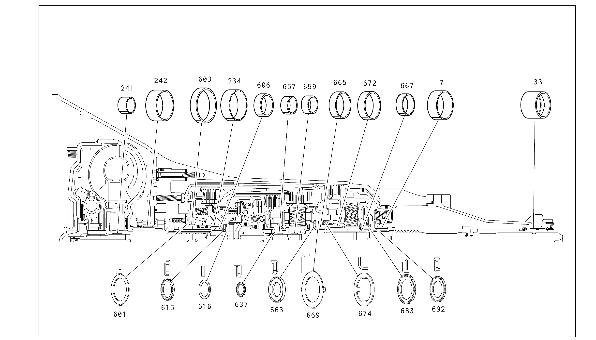
Source: provided 4L60E illustrated parts list, Figure 89.

WEAR ITEMS REFERENCE | Seals and sealing rings
MARKING ACTION: Use the callout number to prevent mixing similar seals. Record damaged, cut, hardened, or missing seals in the relevant inventory line or discrepancy log.
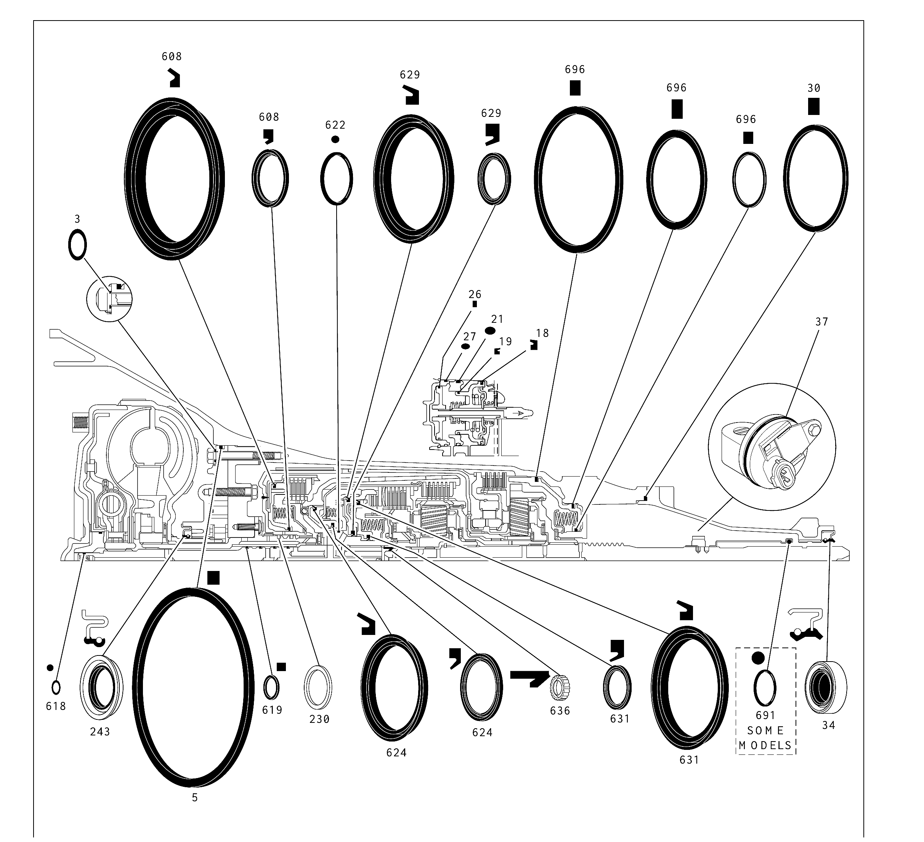
Source: provided 4L60E illustrated parts list, Figure 90.

CASE / EXTERNAL / HYDRAULIC | Exploded view - Panel A
MARKING ACTION: Circle each callout as the component leaves the transmission. Record grouped hardware by actual quantity.
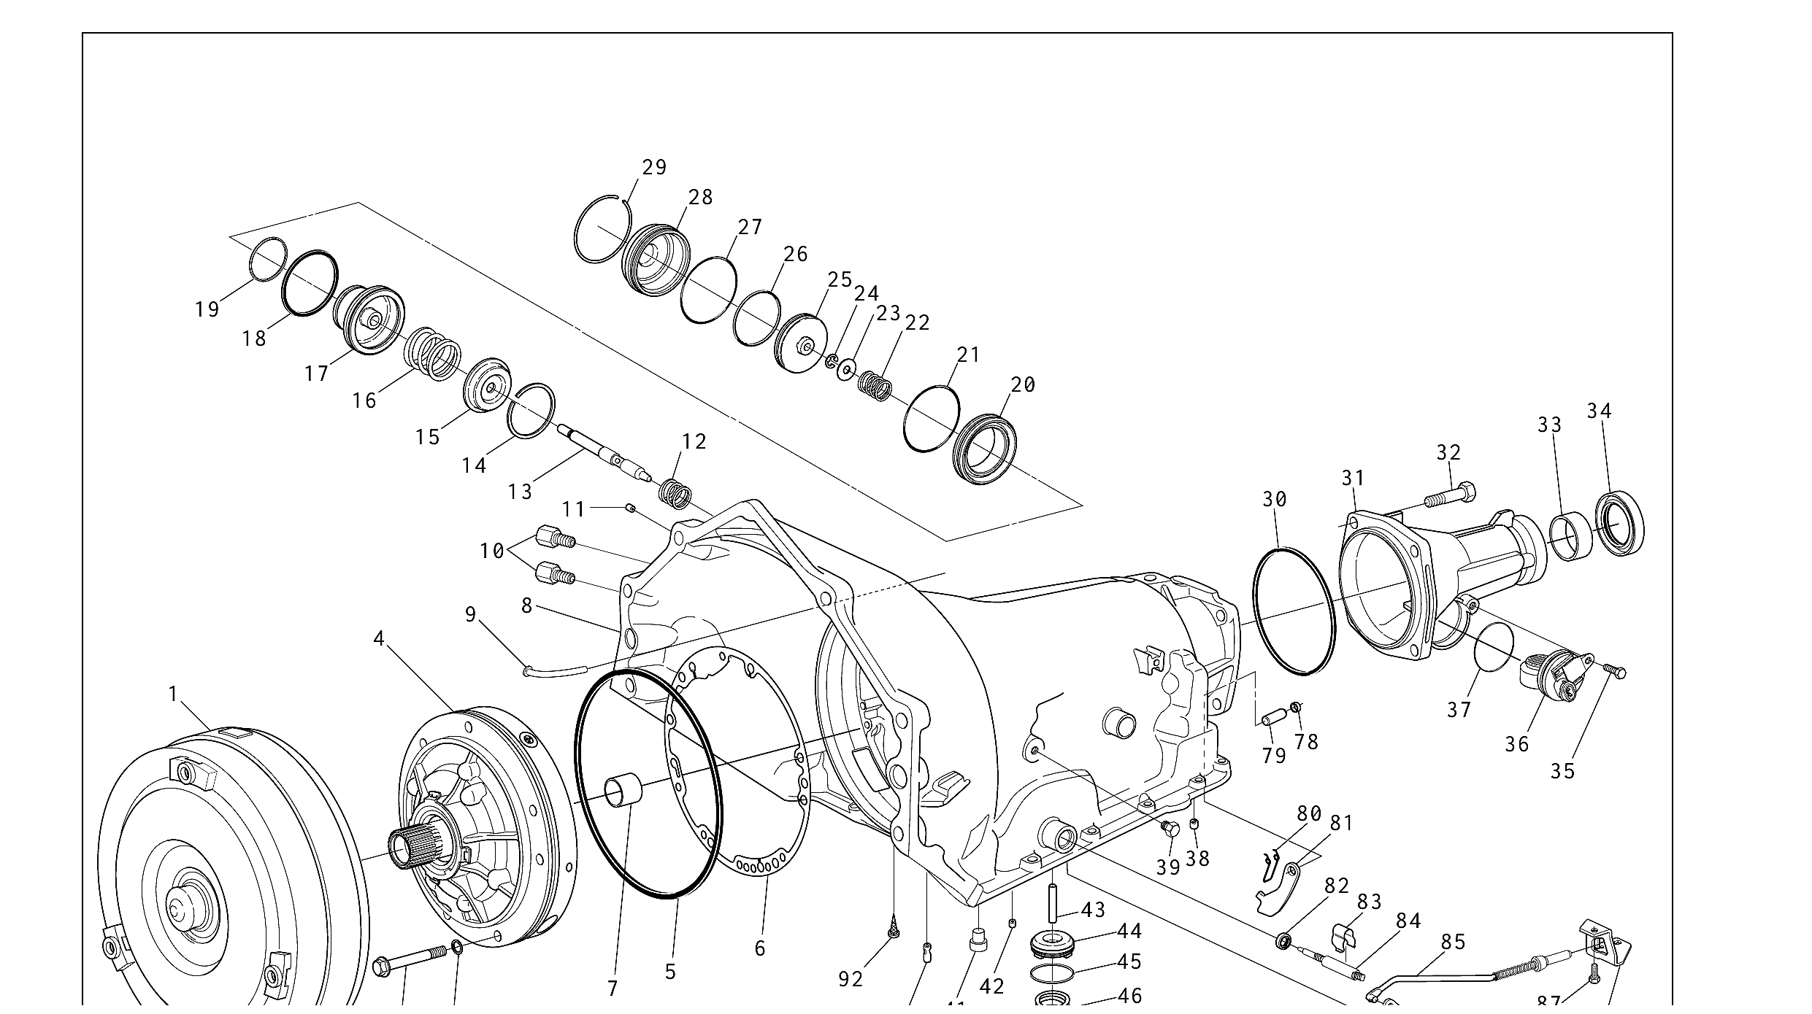
Source: provided 4L60E illustrated parts list, Figure 91.

CASE / EXTERNAL / HYDRAULIC | Exploded view - Panel B
MARKING ACTION: Continue marking on this panel. X through the circle only after the component is reinstalled and the Qty In entry is complete.
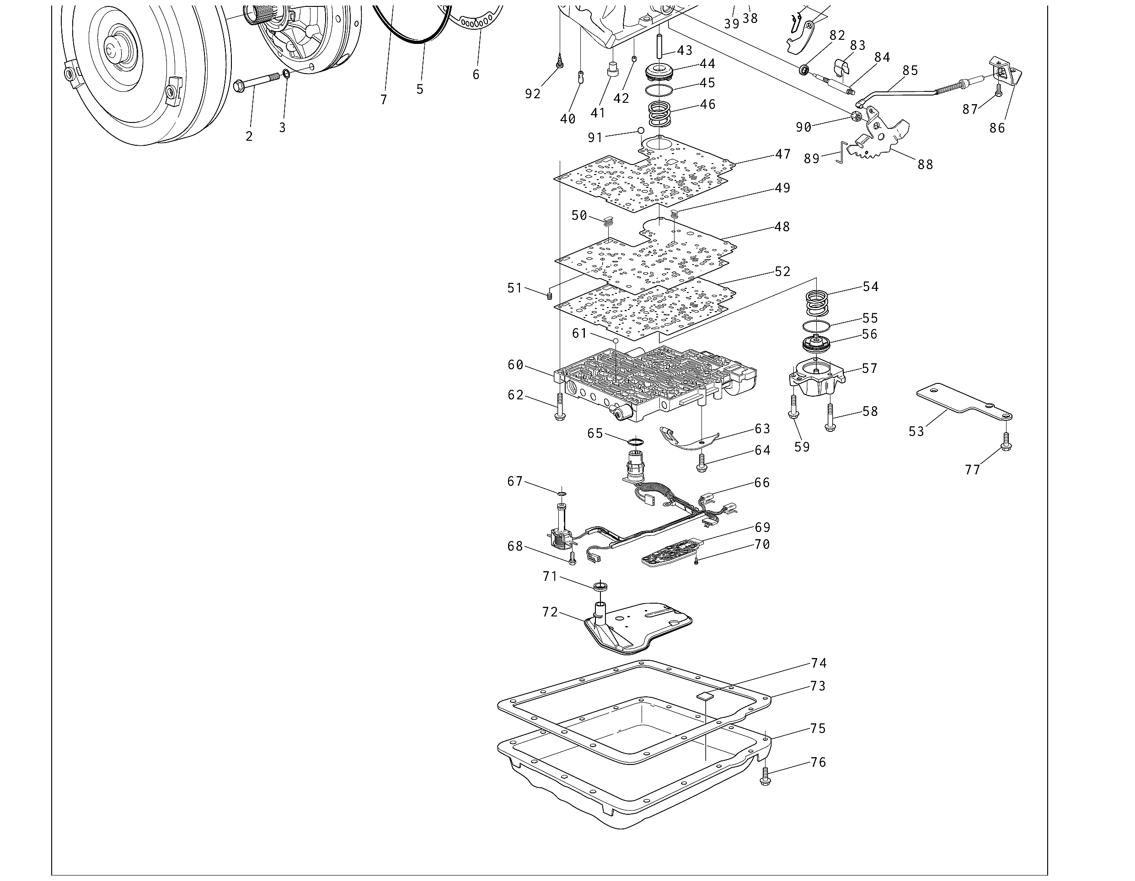
Source: provided 4L60E illustrated parts list, Figure 91.

CASE, EXTERNAL, AND HYDRAULIC COMPONENTS | Inventory Sheet 1 of 5
Marking reminder: Circle the callout when removed. Record the actual count. X through the circle only after reinstallation and count verification.
Ill.  No. | Part description | Qty  out | Tray /  bin | Cond.  code | Replace?  Y / N | Qty  in | Student  initials
1 | TORQUE CONVERTER ASSEMBLY
2 | BOLT, PUMP TO CASE
3 | O-RING, PUMP TO CASE BOLT
4 | PUMP ASSEMBLY, OIL
5 | SEAL, OIL (PUMP TO CASE)
6 | GASKET, PUMP COVER TO CASE
7 | BUSHING, CASE
8 | CASE, TRANSMISSION
9 | VENT ASSEMBLY, TRANSMISSION
10 | CONNECTOR, OIL COOLER PIPE
11 | PLUG, CASE SERVO
12 | SPRING, SERVO RETURN
13 | PIN, 2ND APPLY PISTON
14 | RING, RETAINER (2ND APPLY PISTON)
15 | RETAINER, SERVO CUSHION SPRING
16 | SPRING, SERVO CUSHION
17 | PISTON, 2ND APPLY
18 | RING, OIL SEAL (2ND APPLY PISTON - OUTER)
19 | RING, OIL SEAL (2ND APPLY PISTON - INNER)
20 | HOUSING, SERVO PISTON (INNER)

CASE, EXTERNAL, AND HYDRAULIC COMPONENTS | Inventory Sheet 2 of 5
Marking reminder: Circle the callout when removed. Record the actual count. X through the circle only after reinstallation and count verification.
Ill.  No. | Part description | Qty  out | Tray /  bin | Cond.  code | Replace?  Y / N | Qty  in | Student  initials
21 | SEAL, O-RING
22 | SPRING, SERVO APPLY PIN
23 | WASHER, SERVO APPLY PIN
24 | RING, RETAINER (APPLY PIN)
25 | PISTON, 4TH APPLY
26 | RING, OIL SEAL (4TH APPLY PISTON - OUTER)
27 | SEAL, O-RING (2-4 SERVO COVER)
28 | COVER, 2-4 SERVO
29 | RING, SERVO COVER RETAINING
30 | SEAL, CASE EXTENSION TO CASE
31 | EXTENSION, CASE
32 | BOLT, CASE EXTENSION TO CASE
33 | BUSHING, CASE EXTENSION
34 | SEAL ASSEMBLY, CASE EXTENSION OIL
35 | BOLT, SPEED SENSOR RETAINING
36 | SPEED SENSOR, INTERNAL TRANSMISSION
37 | SEAL, O-RING (ITSS TO CASE EXTENSION)
38 | PLUG, TRANSMISSION CASE (ACCUM. BLEED)
39 | PLUG, PRESSURE
40 | RETAINER AND BALL ASSEMBLY, 3RD ACCUM.

CASE, EXTERNAL, AND HYDRAULIC COMPONENTS | Inventory Sheet 3 of 5
Marking reminder: Circle the callout when removed. Record the actual count. X through the circle only after reinstallation and count verification.
Ill.  No. | Part description | Qty  out | Tray /  bin | Cond.  code | Replace?  Y / N | Qty  in | Student  initials
41 | PIN, BAND ANCHOR
42 | RETAINER AND BALL ASM. (DOUBLE ORIFICE)
43 | PIN, ACCUMULATOR PISTON
44 | PISTON, 3-4 ACCUMULATOR
45 | RING, OIL SEAL (3-4 ACCUMULATOR PISTON)
46 | SPRING, 3-4 ACCUMULATOR
47 | GASKET, SPACER PLATE TO CASE NO. DESCRIPTION
48 | PLATE, VALVE BODY SPACER
49 | SCREEN, SHIFT SOLENOIDS
50 | SCREEN, PRESSURE CONTROL SOLENOID
51 | SCREEN, 3-2 CONTROL SOLENOID
52 | GASKET, SPACER PLATE TO VALVE BODY
53 | PLATE, SPACER PLATE SUPPORT
54 | SPRING, 1-2 ACCUMULATOR
55 | RING, OIL SEAL (1-2 ACCUMULATOR)
56 | PISTON, 1-2 ACCUMULATOR
57 | COVER AND PIN ASSEMBLY, 1-2 ACCUMULATOR
58 | BOLT, ACCUMULATOR COVER
59 | BOLT, ACCUMULATOR COVER
60 | VALVE ASSEMBLY, CONTROL BODY

CASE, EXTERNAL, AND HYDRAULIC COMPONENTS | Inventory Sheet 4 of 5
Marking reminder: Circle the callout when removed. Record the actual count. X through the circle only after reinstallation and count verification.
Ill.  No. | Part description | Qty  out | Tray /  bin | Cond.  code | Replace?  Y / N | Qty  in | Student  initials
61 | CHECKBALL
62 | BOLT, VALVE BODY
63 | SPRING ASSEMBLY, MANUAL DETENT
64 | BOLT, MANUAL DETENT SPRING
65 | SEAL, WIRING HARNESS PASS-THRU CONNECTOR O-RING
66 | SOLENOID ASSEMBLY, WIRING HARNESS
67 | SEAL, O-RING (SOLENOID)
68 | BOLT, HEX WASHER HEAD (SOLENOID)
69 | SWITCH ASSEMBLY, TRANSMISSION PRESSURE
70 | BOLT, PRESSURE SWITCH ASSEMBLY
71 | SEAL, FILTER
72 | FILTER ASSEMBLY, TRANSMISSION OIL
73 | GASKET, TRANSMISSION OIL PAN
74 | MAGNET, CHIP COLLECTOR
75 | PAN, TRANSMISSION OIL
76 | SCREW, TRANSMISSION OIL PAN
77 | BOLT, SPACER PLATE SUPPORT
78 | PLUG, STEEL CUP
79 | SHAFT, PARKING BRAKE PAWL
80 | SPRING, PARKING PAWL RETURN

CASE, EXTERNAL, AND HYDRAULIC COMPONENTS | Inventory Sheet 5 of 5
Marking reminder: Circle the callout when removed. Record the actual count. X through the circle only after reinstallation and count verification.
Ill.  No. | Part description | Qty  out | Tray /  bin | Cond.  code | Replace?  Y / N | Qty  in | Student  initials
81 | PAWL, PARKING BRAKE
82 | SEAL, MANUAL SHAFT
83 | RETAINER, MANUAL SHAFT
84 | SHAFT, MANUAL
85 | ACTUATOR ASSEMBLY, PARKING LOCK
86 | BRACKET, PARKING LOCK
87 | BOLT, PARKING LOCK BRACKET
88 | LEVER, INSIDE DETENT
89 | LINK, MANUAL VALVE
90 | NUT, HEX HEAD
91 | NO. 10 CHECKBALL
92 | SCREEN, TCC

INTERNAL GEARTRAIN / CLUTCHES | Exploded view - Panel A
MARKING ACTION: Keep clutch packs, selective parts, bearings, washers, and snap rings separated by assembly. Circle each callout as removed.
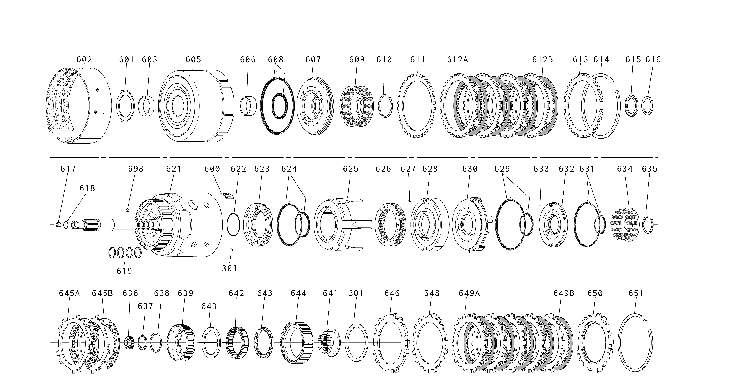
Source: provided 4L60E illustrated parts list, Figure 93.

INTERNAL GEARTRAIN / CLUTCHES | Exploded view - Panel B
MARKING ACTION: Record the actual number of plates, springs, and grouped parts. X through each circle only after count verification during assembly.
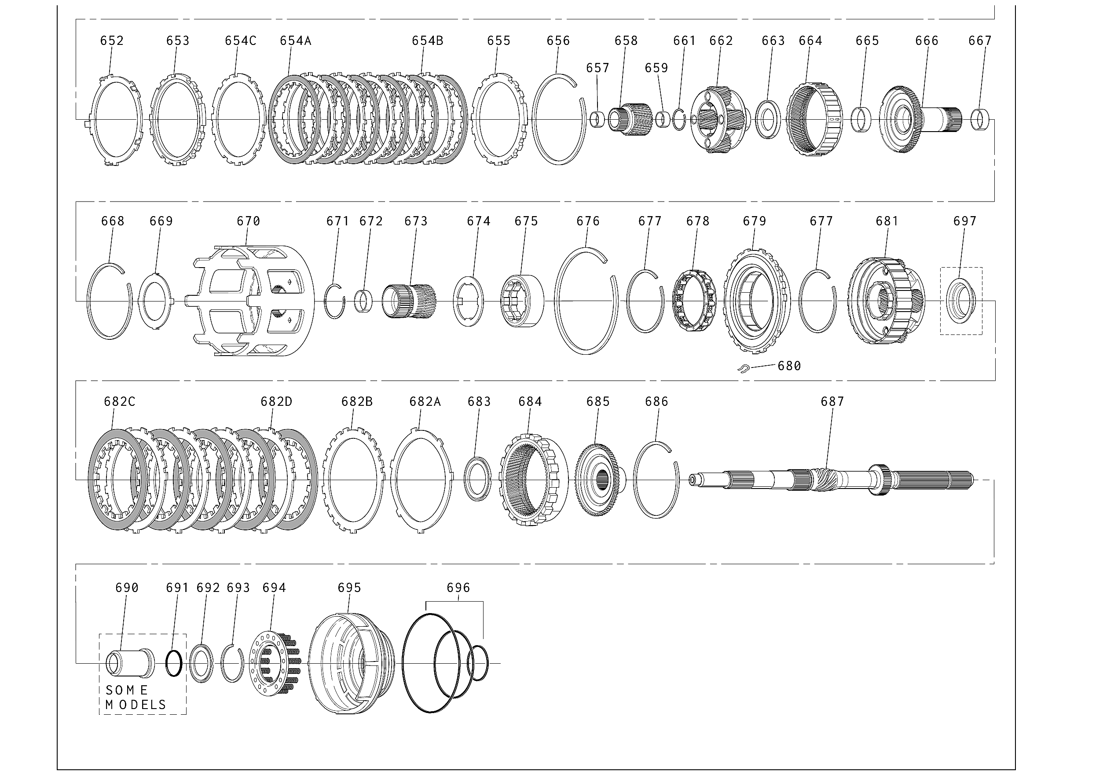
Source: provided 4L60E illustrated parts list, Figure 93.

INTERNAL GEARTRAIN AND CLUTCH COMPONENTS | Inventory Sheet 1 of 6
Marking reminder: Circle the callout when removed. Record the actual count. X through the circle only after reinstallation and count verification.
Ill.  No. | Part description | Qty  out | Tray /  bin | Cond.  code | Replace?  Y / N | Qty  in | Student  initials
600 | SPRING ASM., 3-4 CLUTCH BOOST (5)
601 | WASHER, THRUST (PUMP TO DRUM)
602 | BAND ASSEMBLY, 2-4
603 | BUSHING, REVERSE INPUT CL. (FRONT)
605 | HOUSING AND DRUM ASSEMBLY, REVERSE INPUT CLUTCH
606 | BUSHING, REVERSE INPUT CLUTCH (REAR)
607 | PISTON ASM., REVERSE INPUT CLUTCH
608 | SEALS, REVERSE INPUT CLUTCH (INNER AND OUTER)
609 | SPRING ASM., REVERSE INPUT CLUTCH
610 | RING, REVERSE INPUT CLUTCH SPRING RETAINER
611 | PLATE, REVERSE INPUT CLUTCH (BELLEVILLE)
612A | PLATE ASM., REVERSE INPUT CLUTCH (STEEL)
612B | PLATE, REVERSE INPUT CLUTCH (FIBER)
613 | PLATE, REVERSE INPUT CLUTCH BACKING (SELECTIVE)
614 | RING, REVERSE INPUT CL. RETAINING
615 | BEARING ASSEMBLY, STATOR SHAFT/ SELECTIVE WASHER
616 | WASHER, THRUST (SELECTIVE)
617 | RETAINER AND BALL ASM., CHECK VALVE
618 | SEAL, O-RING (TURBINE SHAFT/ SELECTIVE WASHER)
619 | RING, OIL SEAL (SOLID)

INTERNAL GEARTRAIN AND CLUTCH COMPONENTS | Inventory Sheet 2 of 6
Marking reminder: Circle the callout when removed. Record the actual count. X through the circle only after reinstallation and count verification.
Ill.  No. | Part description | Qty  out | Tray /  bin | Cond.  code | Replace?  Y / N | Qty  in | Student  initials
620 | RETAINER AND CHECKBALL ASSEMBLY
621 | HOUSING AND SHAFT ASSEMBLY, INPUT
622 | SEAL, O-RING INPUT TO FORWARD HSG.
623 | PISTON, 3RD AND 4TH CLUTCH
624 | SEAL, 3RD AND 4TH CL. (INNER AND OUTER)
625 | RING, 3RD AND 4TH CLUTCH (APPLY)
626 | SPRING ASSEMBLY, 3RD AND 4TH CLUTCH
627 | RETAINER AND BALL ASSEMBLY, FORWARD CLUTCH HOUSING
628 | HOUSING, FORWARD CLUTCH
629 | SEAL, FORWARD CLUTCH (INNER AND OUTER)
630 | PISTON, FORWARD CLUTCH
631 | SEAL, OVERRUN CLUTCH (INNER AND OUTER)
632 | PISTON, OVERRUN CLUTCH
633 | BALL, OVERRUN CLUTCH
634 | SPRING ASSEMBLY, OVERRUN CLUTCH
635 | SNAP RING, OVERRUN CLUTCH SPRING RETAINER
636 | SEAL, INPUT HOUSING TO OUTPUT SHAFT
637 | BEARING ASSEMBLY, INPUT SUN GEAR
638 | SNAP RING, OVERRUN CL. HUB RETAINING
639 | HUB, OVERRUN CLUTCH

INTERNAL GEARTRAIN AND CLUTCH COMPONENTS | Inventory Sheet 3 of 6
Marking reminder: Circle the callout when removed. Record the actual count. X through the circle only after reinstallation and count verification.
Ill.  No. | Part description | Qty  out | Tray /  bin | Cond.  code | Replace?  Y / N | Qty  in | Student  initials
641 | RETAINER AND RACE ASSEMBLY, SPRAG
642 | FORWARD SPRAG ASSEMBLY
643 | RETAINER RINGS, SPRAG ASSEMBLY
644 | RACE, FORWARD CLUTCH (OUTER)
645A | PLATE ASSEMBLY, OVERRUN CLUTCH (STEEL)
645B | PLATE, OVERRUN CLUTCH (FIBER)
646 | PLATE, FORWARD CLUTCH (APPLY)
648 | PLATE, FORWARD CLUTCH (WAVED)
649A | PLATE ASSEMBLY, FORWARD CLUTCH (STEEL)
649B | PLATE, FORWARD CLUTCH (FIBER)
650 | PLATE, FORWARD CLUTCH BACKING (SEL.)
651 | RING, FORWARD CLUTCH BACKING PLATE RETAINER
652 | PLATE, 3-4 CLUTCH RING RETAINER
653 | PLATE, 3-4 CLUTCH APPLY (STEPPED) NO. DESCRIPTION
654A | PLATE ASSEMBLY, 3RD AND 4TH CLUTCH (FIBER)
654B | PLATE, 3-4 CLUTCH (STEEL)
654C | PLATE, 3-4 CLUTCH (STEEL)
655 | PLATE, 3-4 CLUTCH BACKING (SEL.)
656 | RING, 3-4 CLUTCH BACKING PLATE RETAINER
657 | BUSHING, INPUT SUN GEAR (FRONT)

INTERNAL GEARTRAIN AND CLUTCH COMPONENTS | Inventory Sheet 4 of 6
Marking reminder: Circle the callout when removed. Record the actual count. X through the circle only after reinstallation and count verification.
Ill.  No. | Part description | Qty  out | Tray /  bin | Cond.  code | Replace?  Y / N | Qty  in | Student  initials
658 | GEAR, INPUT SUN
659 | BUSHING, INPUT SUN GEAR (REAR)
661 | RET., OUTPUT SHAFT TO INPUT CARRIER
662 | CARRIER ASSEMBLY, INPUT (COMPLETE)
663 | BEARING ASSEMBLY, THRUST (INPUT CARRIER TO REACTION SHAFT)
664 | GEAR, INPUT INTERNAL
665 | BUSHING, REACTION CARRIER SHAFT (FRONT)
666 | SHAFT, REACTION CARRIER
667 | BUSHING, REACTION CARRIER SHAFT (REAR)
668 | RING, REACTION SHAFT/INTERNAL GEAR RETAINER
669 | WASHER, THRUST (REACTION SHAFT/SHELL)
670 | SHELL, REACTION SUN
671 | RING, REACTION SUN GEAR RETAINER
672 | BUSHING, REACTION SUN
673 | GEAR, REACTION SUN
674 | WASHER, THRUST (RACE/REACTION SHELL)
675 | RACE, LO ROLLER CLUTCH
676 | RING, LO AND REVERSE SUPPORT TO CASE RETAINER
677 | RING, LO AND REVERSE RETAINER (ROLLER ASSEMBLY/CAM)
678 | CLUTCH ASSEMBLY, LO ROLLER

INTERNAL GEARTRAIN AND CLUTCH COMPONENTS | Inventory Sheet 5 of 6
Marking reminder: Circle the callout when removed. Record the actual count. X through the circle only after reinstallation and count verification.
Ill.  No. | Part description | Qty  out | Tray /  bin | Cond.  code | Replace?  Y / N | Qty  in | Student  initials
679 | SUPPORT ASM., LO AND REVERSE CLUTCH
680 | SPRING, TRANSMISSION (LO AND REVERSE CLUTCH SUPPORT RETAINER)
681 | CARRIER ASSEMBLY, REACTION
682A | PLATE, LO AND REVERSE CLUTCH (WAVED)
682B | PLATE, SPACER LO AND REVERSE CLUTCH (SELECTIVE)
682C | PLATE ASSEMBLY, LO AND REVERSE CLUTCH (FIBER)
682D | PLATE, LO AND REVERSE CLUTCH (STEEL)
683 | BEARING ASSEMBLY, THRUST (REACTION CARRIER/ SUPPORT)
684 | GEAR, INTERNAL REACTION
685 | SUPPORT, INTERNAL REACTION GEAR
686 | RING, REACTION GEAR/SUPPORT RETAINER
687 | SHAFT, OUTPUT
690 | SLEEVE, OUTPUT SHAFT
691 | SEAL, OUTPUT SHAFT
692 | BRG., REACTION GEAR SUPPORT TO CASE
693 | RING, LO AND REVERSE CLUTCH RETAINER
694 | SPRING ASSEMBLY, LO AND REVERSE CLUTCH
695 | PISTON, LO AND REVERSE CLUTCH
696 | SEAL, TRANSMISSION (LO AND REVERSE CLUTCH - OUTER, CENTER, INNER)
697 | DEFLECTOR, OIL (HIGH OUTPUT MODELS ONLY)

INTERNAL GEARTRAIN AND CLUTCH COMPONENTS | Inventory Sheet 6 of 6
Marking reminder: Circle the callout when removed. Record the actual count. X through the circle only after reinstallation and count verification.
Ill.  No. | Part description | Qty  out | Tray /  bin | Cond.  code | Replace?  Y / N | Qty  in | Student  initials
698 | PLUG, ORIFICED CUP
699 | ROTOR, INTERNAL TRANSMISSION SPEED SENSOR

VALVE BODY | Exploded view - Panel A
MARKING ACTION: Work one bore at a time. Circle the callout, record the location, and keep each valve train in exact removal order.
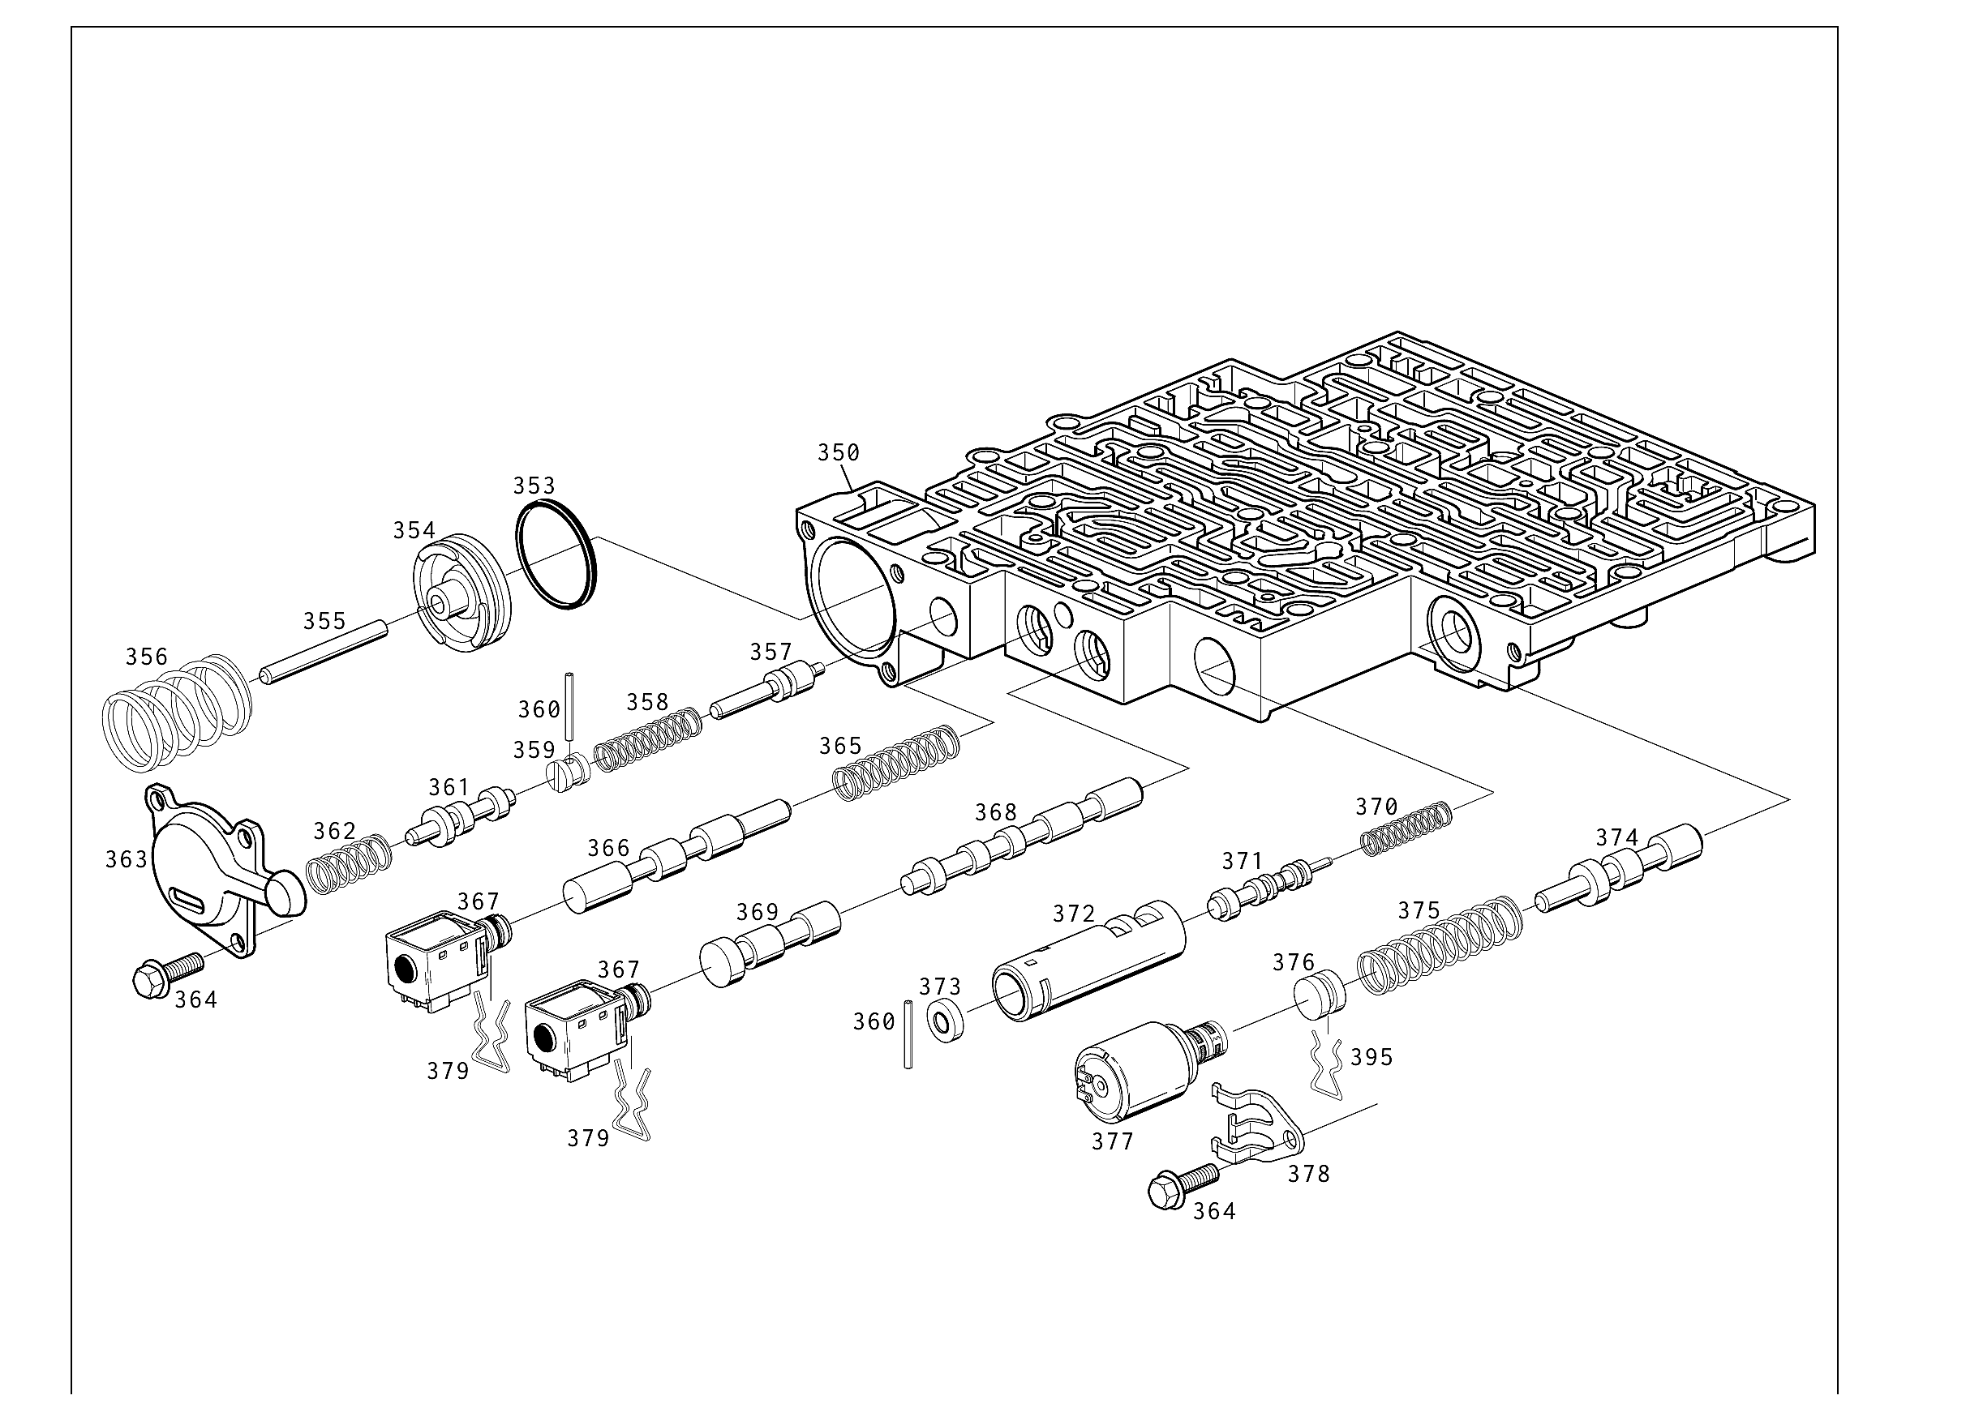
Source: provided 4L60E illustrated parts list, Figure 95.

VALVE BODY | Exploded view - Panel B
MARKING ACTION: Do not combine springs, plugs, retainers, or valves from different bores. Use the inventory table to verify each return.
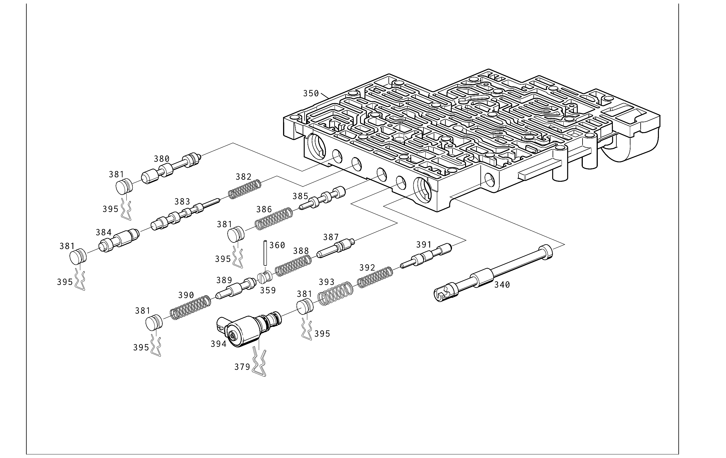
Source: provided 4L60E illustrated parts list, Figure 95.

VALVE BODY COMPONENTS | Inventory Sheet 1 of 3
Marking reminder: Circle the callout when removed. Record the actual count. X through the circle only after reinstallation and count verification.
Ill.  No. | Part description | Qty  out | Tray /  bin | Cond.  code | Replace?  Y / N | Qty  in | Student  initials
340 | VALVE, MANUAL
350 | VALVE ASSEMBLY, CONTROL BODY
353 | SEAL, FORWARD ACCUMULATOR OIL
354 | PISTON, FORWARD ACCUMULATOR
355 | PIN, FORWARD ACCUMULATOR
356 | SPRING, FORWARD ACCUMULATOR
357 | VALVE, FORWARD ABUSE
358 | SPRING, FORWARD ABUSE VALVE
359 | PLUG, BORE
360 | PIN, COILED SPRING
361 | VALVE, LOW OVERRUN
362 | SPRING, LOW OVERRUN VALVE
363 | COVER, FORWARD ACCUMULATOR
364 | BOLT, FORWARD ACCUMULATOR COVER
365 | SPRING, 1-2 SHIFT VALVE
366 | VALVE, 1-2 SHIFT
367A | SHIFT SOLENOID A (1-2/3-4)
367B | SHIFT SOLENOID B (2-3)
368 | VALVE, 2-3 SHIFT
369 | VALVE, 2-3 SHUTTLE

VALVE BODY COMPONENTS | Inventory Sheet 2 of 3
Marking reminder: Circle the callout when removed. Record the actual count. X through the circle only after reinstallation and count verification.
Ill.  No. | Part description | Qty  out | Tray /  bin | Cond.  code | Replace?  Y / N | Qty  in | Student  initials
370 | SPRING, ACCUMULATOR VALVE
371 | VALVE, ACCUMULATOR
372 | SLEEVE, ACCUMULATOR VALVE
373 | PLUG, BORE
374 | VALVE, ACTUATOR FEED LIMIT
375 | SPRING, ACTUATOR FEED LIMIT VALVE
376 | PLUG, BORE
377 | PRESSURE CONTROL SOLENOID
378 | RETAINER, PRESSURE CONTROL SOLENOID
379 | RETAINER, SOLENOID
380 | VALVE, CONVERTER CLUTCH SIGNAL
381 | PLUG, BORE
382 | SPRING, 4-3 SEQUENCE VALVE
383 | VALVE, 4-3 SEQUENCE
384 | VALVE, 3-4 RELAY
385 | VALVE, 3-4 SHIFT
386 | SPRING, 3-4 SHIFT VALVE
387 | VALVE, REVERSE ABUSE
388 | SPRING, REVERSE ABUSE VALVE
389 | VALVE, 3-2 DOWNSHIFT

VALVE BODY COMPONENTS | Inventory Sheet 3 of 3
Marking reminder: Circle the callout when removed. Record the actual count. X through the circle only after reinstallation and count verification.
Ill.  No. | Part description | Qty  out | Tray /  bin | Cond.  code | Replace?  Y / N | Qty  in | Student  initials
390 | SPRING, 3-2 DOWNSHIFT VALVE
391 | VALVE, 3-2 CONTROL
392 | SPRING, 3-2 CONTROL VALVE
393 | SPRING, BORE PLUG
394 | 3-2 CONTROL SOLENOID
395 | RETAINER, BORE PLUG

OIL PUMP | Exploded view - Panel A
MARKING ACTION: Circle each pump callout as removed. Record small valves, plugs, balls, springs, rings, and retainers immediately.
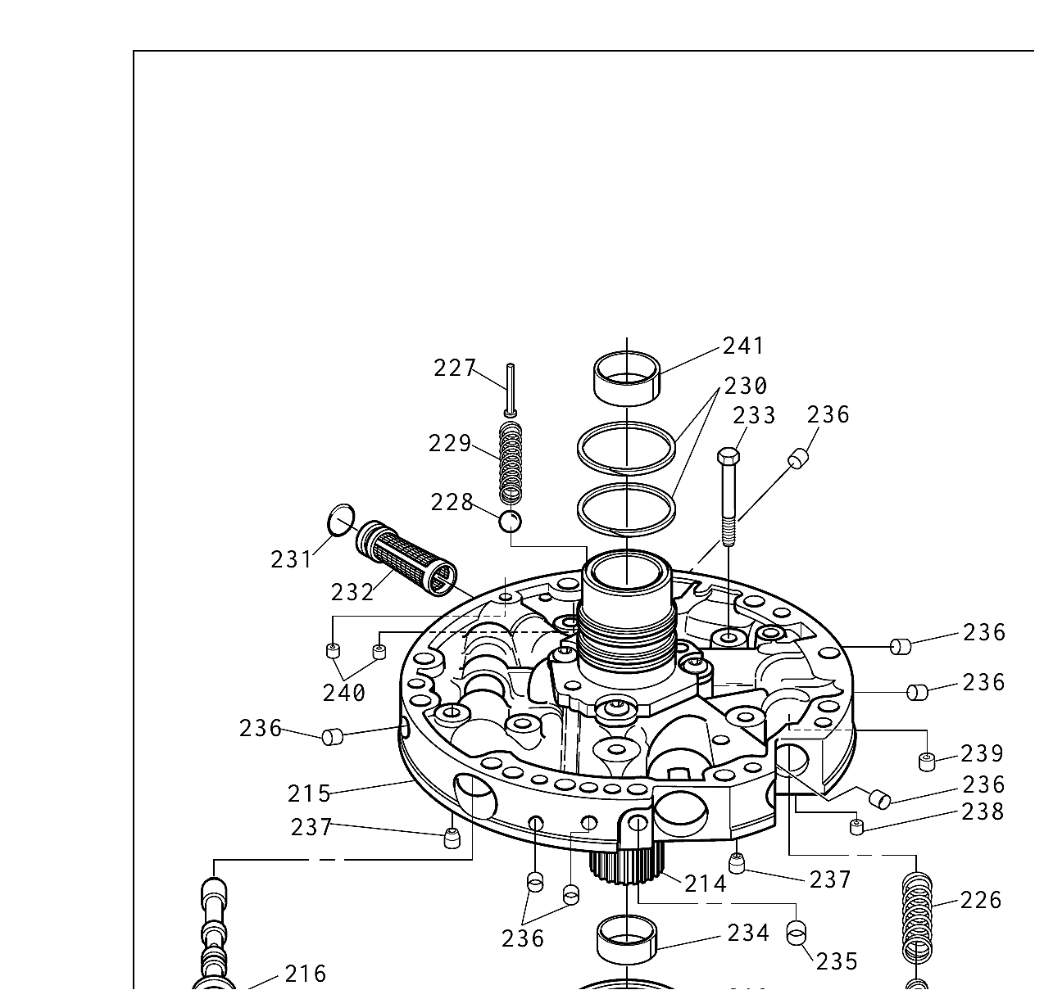
Source: provided 4L60E illustrated parts list, Figure 97.

OIL PUMP | Exploded view - Panel B
MARKING ACTION: Verify orientation and count before reinstallation. X through the circle after the part is returned and recorded.
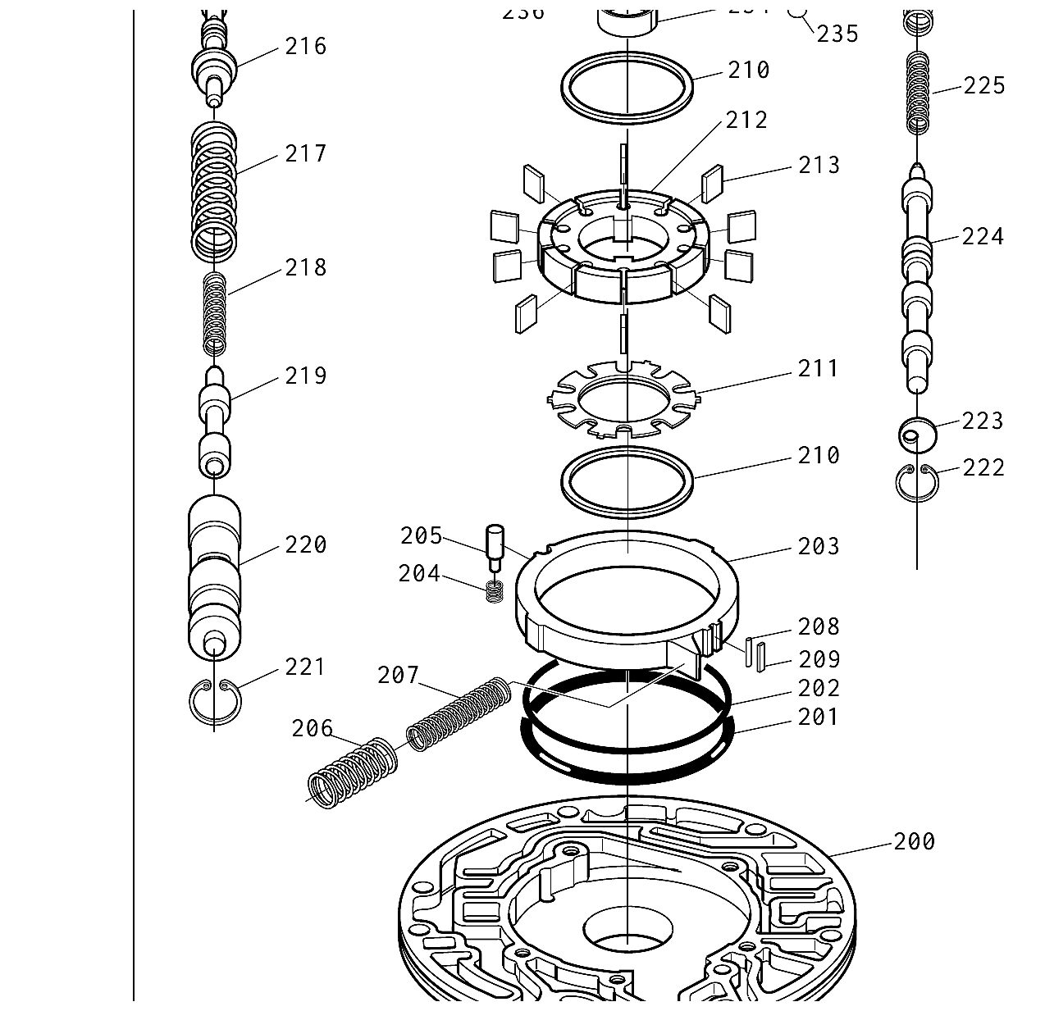
Source: provided 4L60E illustrated parts list, Figure 97.

OIL PUMP | Exploded view - Panel C
MARKING ACTION: Complete the lower pump assembly callouts, then reconcile all pump inventory lines before the pump is returned to the case.
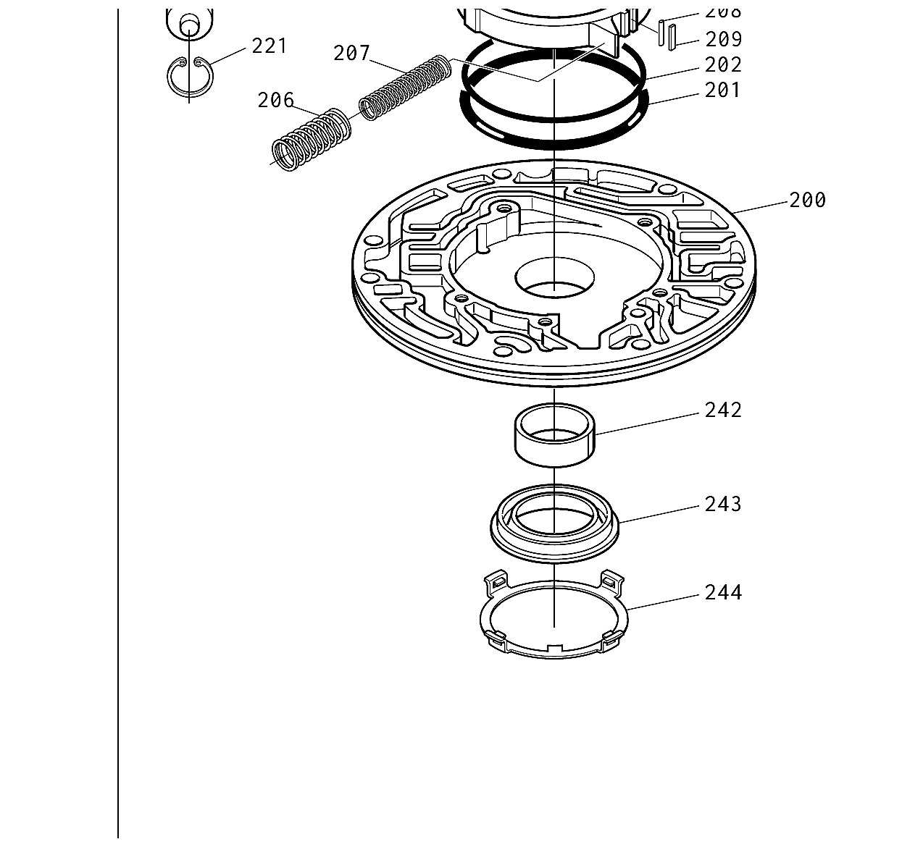
Source: provided 4L60E illustrated parts list, Figure 97.

OIL PUMP COMPONENTS | Inventory Sheet 1 of 3
Marking reminder: Circle the callout when removed. Record the actual count. X through the circle only after reinstallation and count verification.
Ill.  No. | Part description | Qty  out | Tray /  bin | Cond.  code | Replace?  Y / N | Qty  in | Student  initials
200 | BODY, PUMP
201 | RING, OIL SEAL (SLIDE TO WEAR PLATE)
202 | SEAL, O-RING (SLIDE SEAL BACK-UP)
203 | SLIDE, PUMP
204 | SPRING, PIVOT PIN
205 | PIN, PIVOT SLIDE
206 | SPRING, PUMP SLIDE (OUTER)
207 | SPRING, PUMP SLIDE (INNER)
208 | SUPPORT, PUMP SLIDE SEAL
209 | SEAL, PUMP SLIDE
210 | RING, PUMP VANE
211 | GUIDE, ROTOR
212 | ROTOR, OIL PUMP
213 | VANE, PUMP
214 | SHAFT, STATOR
215 | COVER, PUMP
216 | VALVE, PRESSURE REGULATOR
217 | SPRING, PRESSURE REGULATOR VALVE
218 | SPRING, PRESSURE REGULATOR ISOLATOR
219 | VALVE, REVERSE BOOST

OIL PUMP COMPONENTS | Inventory Sheet 2 of 3
Marking reminder: Circle the callout when removed. Record the actual count. X through the circle only after reinstallation and count verification.
Ill.  No. | Part description | Qty  out | Tray /  bin | Cond.  code | Replace?  Y / N | Qty  in | Student  initials
220 | SLEEVE, REVERSE BOOST VALVE
221 | RING, OIL PUMP REVERSE BOOST VALVE RETAINING
222 | RING, OIL PUMP CONVERTER CLUTCH VALVE RETAINING
223 | VALVE, STOP
224 | VALVE, CONVERTER CLUTCH
225 | SPRING, CONVERTER CLUTCH VALVE (INNER)
226 | SPRING, CONVERTER CLUTCH VALVE (OUTER)
227 | RIVET, PRESSURE RELIEF BOLT
228 | BALL, PRESSURE RELIEF
229 | SPRING PRESSURE RELIEF
230 | RING, OIL SEAL (STATOR SHAFT)
231 | SEAL, OIL PUMP COVER SCREEN
232 | SCREEN, OIL PUMP COVER
233 | BOLT, M8 X 1.25 X 40 (COVER TO BODY)
234 | BUSHING, STATOR SHAFT (FRONT)
235 | PLUG, OIL PUMP COVER (FWD CLUTCH FEED)
236 | PLUG, OIL PUMP COVER
237 | RETAINER AND BALL ASSEMBLY, CHECK VALVE
238 | ORIFICE, CONVERTER CLUTCH SIGNAL (CUP PLUG)
239 | ORIFICE, OIL COOLER (CUP PLUG)

OIL PUMP COMPONENTS | Inventory Sheet 3 of 3
Marking reminder: Circle the callout when removed. Record the actual count. X through the circle only after reinstallation and count verification.
Ill.  No. | Part description | Qty  out | Tray /  bin | Cond.  code | Replace?  Y / N | Qty  in | Student  initials
240 | PLUG, CUP ORIFICE
241 | BUSHING, STATOR SHAFT (REAR)
242 | BUSHING, PUMP BODY
243 | SEAL ASSEMBLY, OIL
244 | RETAINER, FRONT HELIX

FINAL INVENTORY RECONCILIATION
[ ] Every removed callout has a circle and an X. | [ ] Qty Out equals Qty In for every inventoried line. | [ ] All trays, bins, towels, and work surfaces are empty of unexplained parts.
[ ] All checkballs, seals, rings, washers, bearings, bushings, and snap rings are accounted for. | [ ] Every replaced part is identified and the removed part is accounted for. | [ ] Every unresolved item is entered in the discrepancy log below.

DISCREPANCY / LEFTOVER PARTS LOG
Ill. No. | Part / item | Issue | Corrective action | Instructor initials

ASSEMBLY SIGN-OFF
Case / hydraulic | Internal geartrain / clutches | Valve body | Oil pump
Student: ____________ Instructor: ____________ | Student: ____________ Instructor: ____________ | Student: ____________ Instructor: ____________ | Student: ____________ Instructor: ____________

