HANDS-ON PERFORMANCE TASK
4L60E Valve Body Installation
Student checkoff procedure for correct hydraulic stack-up, electrical connection, bolt placement, torque, filter, and pan installation.
UNIT  4L60E | VALVE BODY  8 ft-lb | PAN  9 ft-lb | CHECKBALLS  7

Student | ____________________________ | Date | __________________
Partner | ____________________________ | Unit ID | __________________

Performance Objective
Objective: Install the 4L60E valve body and related components in the correct order without damaging the case, gaskets, wiring, solenoids, fasteners, or hydraulic components. Meet all listed inspection and torque requirements.

SAFETY AND WORK HABITS  [ ] Wear safety glasses and protective gloves.  [ ] Keep the bench, case, and parts clean.  [ ] Clean fluid spills immediately.  [ ] Use hand tools only until final torque.  [ ] Stop if a part does not seat correctly. | REQUIRED TOOLS AND MATERIALS  [ ] Inch-pound or low-range ft-lb torque wrench  [ ] Correct sockets and two alignment pins  [ ] Assembly lube and lint-free wipes  [ ] New O-rings, filter, and pan gasket  [ ] C and V gaskets, separator plate, 7 checkballs

Phase 1 - Case Preparation
Done | # | Student Performance Task | Verify / Initial
[ ] | 1 | Inventory the parts. Separate bolts by length and location. Report any missing or damaged parts before beginning.
[ ] | 2 | Inspect the case, valve body, separator plate, gasket surfaces, and passages. Remove debris without scratching sealing surfaces.
[ ] | 3 | Install the 3-4 accumulator piston pin. Fit a new piston seal and apply assembly lube inside the bore.
[ ] | 4 | Install the 3-4 accumulator piston with the open side facing up, then install its spring.
[ ] | 5 | Place checkball #91 in the case pocket next to the 3-4 accumulator.
[ ] | 6 | Verify the low-reverse capsule contains its checkball. Do not add other loose case checkballs to a 4L60E.
[ ] | 7 | Confirm the band anchor pin is fully seated, then install two valve-body alignment pins in the specified holes.
STOP POINT - A - CASE READY: Instructor verifies cleanliness, accumulator orientation, #91 checkball, capsule checkball, band anchor pin, and alignment pins. | Instructor: __________________  Date/Time: ________________
Reference: Valvebody Installation PDF, manual pages 162-176. Always follow the instructor's unit-specific direction if the classroom unit differs.

PHASE 2 - HYDRAULIC STACK-UP | Gaskets, separator plate, accumulator housing, and checkballs

Critical identification: The case gasket is marked C. The valve-body gasket is marked V. Reversing, misaligning, or pinching these gaskets can create cross-leaks and shift complaints.

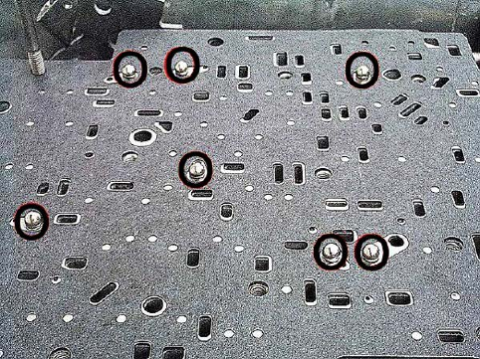
4L60E separator-plate checkball map - verify all seven positions before lowering the valve body.
Done | # | Student Performance Task | Verify / Initial
[ ] | 8 | Place the case gasket marked C onto the case. Align every passage and bolt hole.
[ ] | 9 | Verify the 4L60E separator-plate screens are present and correctly seated.
[ ] | 10 | Lower the separator plate onto the case gasket without moving the gasket.
[ ] | 11 | Place the valve-body gasket marked V on top of the separator plate. Confirm full alignment.
[ ] | 12 | Install the correct separator stiffener plate for this unit as directed by the instructor.
[ ] | 13 | Install the 1-2 accumulator housing with the correct bolts. Torque the bolts to 8 ft-lb.
[ ] | 14 | Apply small dabs of assembly lube at the seven specified checkball locations. Install exactly seven checkballs.
[ ] | 15 | Insert the S-shaped end of the manual-valve link into the manual lever.
STOP POINT - B - HYDRAULIC STACK APPROVED: Do not lower the valve body until the instructor verifies C/V gasket order, screens, separator plate, 1-2 housing torque, seven checkballs, and manual link. | Instructor: __________________  Date/Time: ________________

Phase 3 - Electrical Components and Valve Body
Done | # | Student Performance Task | Verify / Initial
[ ] | 16 | Install new O-rings on the solenoid harness case connector and TCC solenoid. Lightly lubricate each O-ring.
[ ] | 17 | Install the harness into the case. Position the TCC solenoid correctly and install its retaining bolt.
[ ] | 18 | Move the harness clear of the gasket. Carefully lower the valve body while guiding the manual-valve link into the manual valve.
[ ] | 19 | Position the pressure-switch assembly. Install the correct bolts through it, but leave them loose.

PHASE 3 CONTINUED - BOLT PLACEMENT AND TORQUE | Wrong bolt length can damage the transmission

High-risk warning: Check every bolt length and location before tightening. An incorrect bolt in a middle valve-body hole can contact the sun gear shell and cause wrong-gear starts or bind-ups.

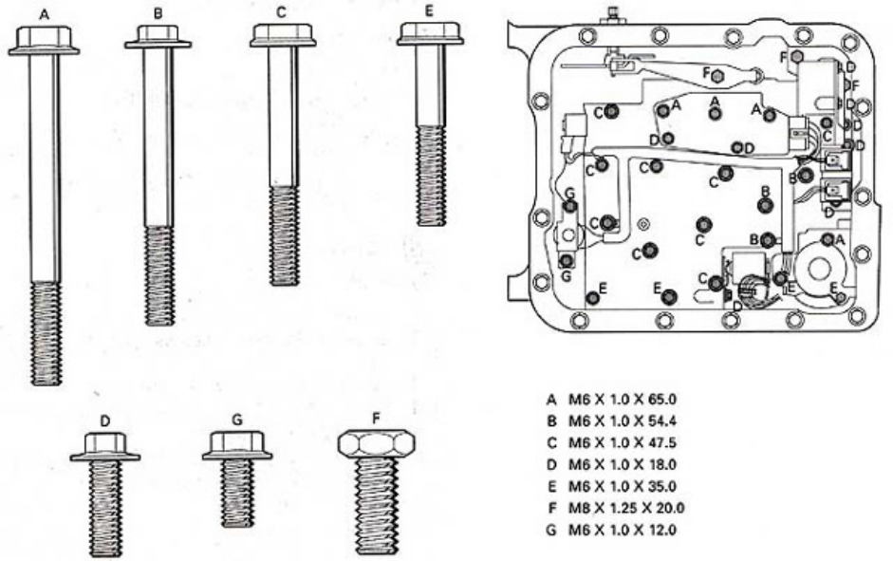
Valve-body bolt identification and location chart. Match each bolt letter and length before torque.
Done | # | Student Performance Task | Verify / Initial
[ ] | 20 | Lay the harness in its correct routing. Connect every solenoid and pressure-switch connector; confirm each latch locks.
[ ] | 21 | Install the proper bolts through the harness hold-down eyes. Remove both alignment pins and install the remaining bolts.
[ ] | 22 | Install the dipstick stop clip at the front corner of the valve body.
[ ] | 23 | Match every bolt to the bolt-location chart. Place all bolts finger-tight and obtain instructor approval before torque.
[ ] | 24 | Torque valve-body bolts to 8 ft-lb using the numbered 1-19 sequence on page 4, beginning in the middle and working outward.
[ ] | 25 | Repeat the complete torque pattern at least once. Record final torque and wrench ID below.
[ ] | 26 | Install the manual-lever detent spring and its bolt.
[ ] | 27 | Coat the neck of a new filter with assembly lube and fully install the filter.
STOP POINT - C - TORQUE VERIFIED: Instructor verifies bolt lengths, bolt locations, harness routing, connectors, dipstick stop clip, torque sequence, and final 8 ft-lb torque. | Instructor: __________________  Date/Time: ________________
Torque wrench ID | ____________________ | Final setting | 8 ft-lb
First pass | [ ] Complete | Second pass | [ ] Complete

Phase 4 - Pan Installation and Final Inspection
Done | # | Student Performance Task | Verify / Initial
[ ] | 28 | Place the magnet in its correct location inside the clean pan.
[ ] | 29 | Install a new pan gasket on the case rail and lower the pan into place without shifting the gasket.
[ ] | 30 | Start every pan bolt by hand before tightening any bolt. Torque the pan bolts to 9 ft-lb; repeat the pattern once.
[ ] | 31 | Complete the final inspection: filter seated, harness not pinched, connectors locked, manual linkage operating, pan gasket aligned, and work area clean.

KNOWLEDGE CHECK AND INSTRUCTOR EVALUATION | Complete before submitting the unit

Torque Sequence Reference
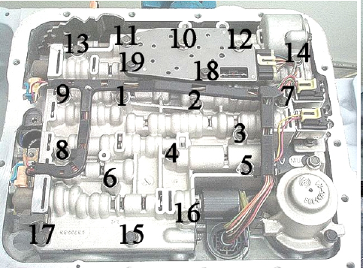
Use the numbered 1-19 sequence for the first and second 8 ft-lb valve-body torque passes.

Final Quality-Control Checklist
HYDRAULIC / MECHANICAL  [ ] C gasket below separator plate  [ ] V gasket above separator plate  [ ] Seven valve-body checkballs installed  [ ] 1-2 accumulator housing torqued  [ ] Manual valve link fully engaged  [ ] Filter fully seated | ELECTRICAL / FASTENERS  [ ] New connector and TCC O-rings installed  [ ] All connector latches locked  [ ] Harness routed and retained  [ ] Correct bolt length in every hole  [ ] Valve-body torque repeated at 8 ft-lb  [ ] Pan torque repeated at 9 ft-lb

Knowledge Check
1 | What does the C identify, and where does that gasket belong?  ________________________________________________________________________________________________
2 | What does the V identify, and where does that gasket belong?  ________________________________________________________________________________________________
3 | Why must every valve-body bolt length be verified before tightening?  ________________________________________________________________________________________________
4 | Why is the valve body torqued from the center outward and the pattern repeated?  ________________________________________________________________________________________________
5 | Name two problems that a pinched harness, unlocked connector, or damaged O-ring could cause.  ________________________________________________________________________________________________

Instructor Evaluation
Result | [ ] Satisfactory [ ] Needs correction [ ] Not completed
Corrections
Student | Signature: ________________________________ Date: ____________
Instructor | Signature: ________________________________ Date: ____________
Score | ________ / 100
Successful completion requires correct assembly, verified torque, safe work habits, and an approved final inspection.

