Build an 8 AA Battery Pack
A fused portable power source built inside a small wooden box
This guide uses a commercial 8-cell series holder, a fuse, a master switch, and insulated output posts. Use the pack only for low-current projects within the ratings of every component.
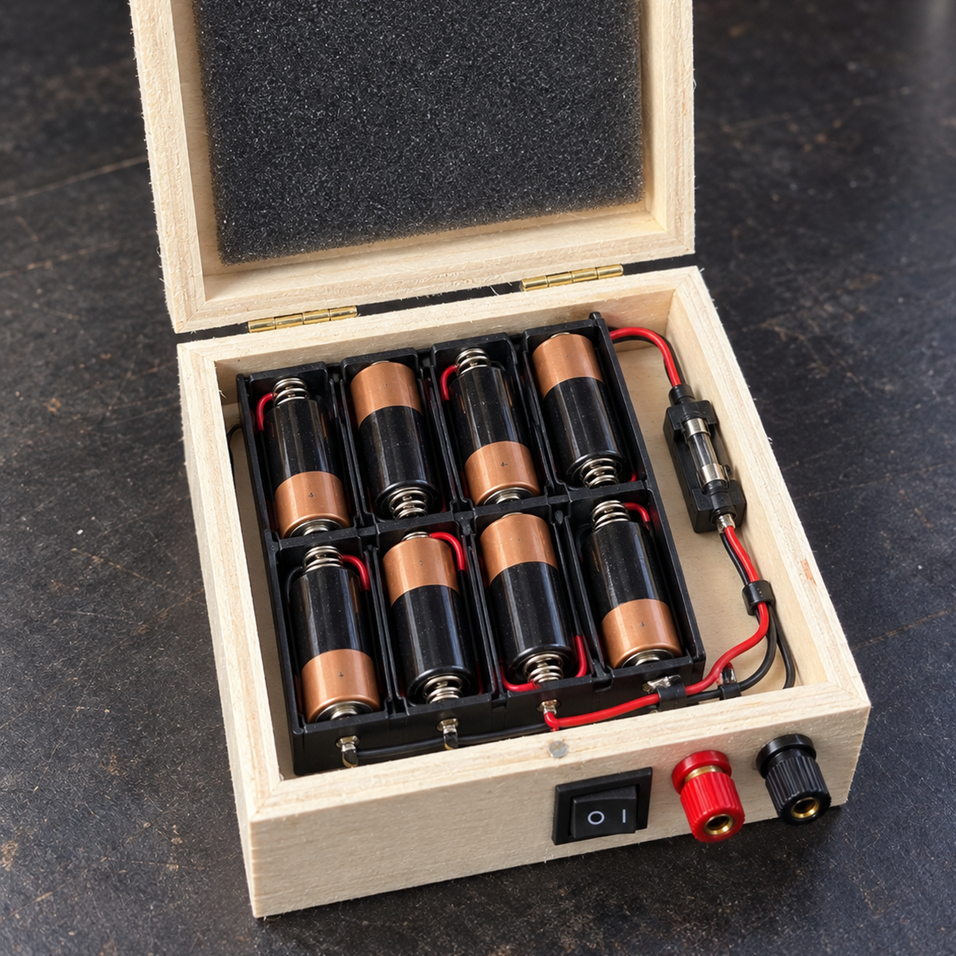
Concept mockup. Confirm the actual component dimensions before cutting or drilling.
Battery type | Per cell | Pack output | Important note
Alkaline | 1.5 V | 12.0 V nominal | Do not recharge. Fresh cells may measure above 12 V.
NiMH rechargeable | 1.2 V | 9.6 V nominal | Remove cells and use an approved NiMH charger.

Parts and tools
Qty | Part | Qty | Part
1 | 8-AA series battery holder with leads | 1 | Small hinged wooden box
8 | Matched AA cells of one chemistry | 1 | SPST rocker switch rated at least 3 A at 12 VDC
1 | Inline fuse holder | 1 | 1 A fuse to start, or the smallest fuse that runs the load
1 ea | Red and black insulated binding posts | 3 ft | 18-22 AWG stranded red and black wire
As needed | Crimp terminals or solder and heat-shrink | 1 | Thin closed-cell foam pad for the lid
As needed | Small screws, standoffs, or secure adhesive | Tools | Ruler, drill, bits, stripper, crimper, multimeter, eye protection

Build and Test the Battery Pack
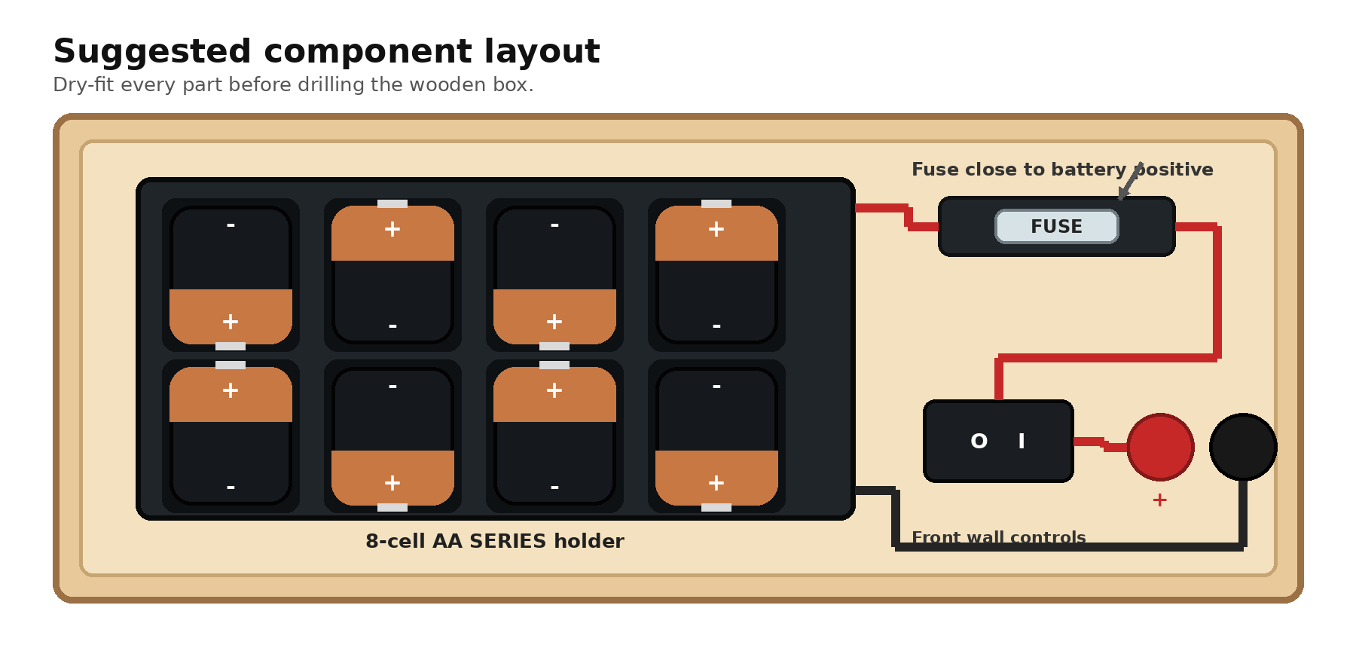
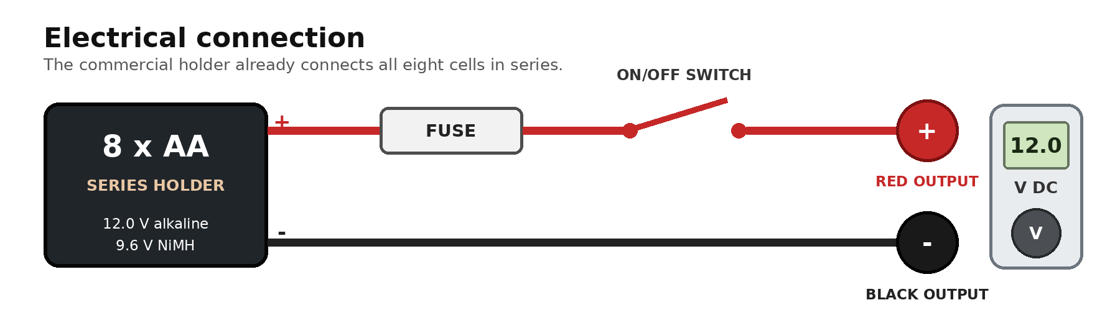

Assembly procedure
Step | Action | Check
1 | Dry-fit the holder, fuse, switch, posts, wiring, and lid foam. Close the lid gently before drilling. | No part is crushed or pinched.
2 | Mark the switch and post holes on the front wall. Remove all parts, drill pilot holes, enlarge carefully, and smooth splinters. | Hardware sits straight and clears the lid.
3 | Mount the holder and fuse securely. Mount the rocker switch and insulated red and black posts. Do not leave metal terminals touching wood or each other. | Nothing moves when the box is tilted.
4 | With no batteries installed, connect holder positive to fuse, fuse to switch, and switch to the red post. Connect holder negative to the black post. | Heat-shrink covers every joint.
5 | Inspect polarity and continuity. With the switch OFF, verify there is no low-resistance short between the red and black posts. | No short circuit is present.
6 | Insert eight matched cells exactly as marked. Set the meter to DC volts, connect black to black and red to red, then switch ON. | About 12 V alkaline or 9.6 V NiMH.

Safety and use limits
- Never short the output posts. Install the fuse before inserting the batteries.
- Use matched cells of one brand, chemistry, and age. Remove them for storage and discard any leaking or damaged cell.
- Use only for low-current electronics, demonstrations, LEDs, and small test circuits - never starters, heaters, high-current motors, or vehicle circuits.
- If any component becomes warm, switch OFF and disconnect the load immediately.

