ELECTRICAL 1 • STUDENT WORKBOOK
Electrical Components
Identify parts • Build safely • Measure behavior • Diagnose faults • Explain the circuit

STUDENT ________________________________ | INSTRUCTOR ________________________________
CLASS / PERIOD ________________________________ | DATE STARTED ________________________________

Your learning roadmap
01 IDENTIFY  Name the part and terminals | 02 BUILD  Create a complete current path | 03 MEASURE  Use evidence, not guesses | 04 DIAGNOSE  Isolate faults and explain why

SUCCESS STANDARD A working circuit is only the beginning. You must also trace the current path, record a measurement, locate a likely fault, and explain the result in your own words.

Safety agreement
- Battery disconnected while installing or moving components.
- Polarity and transistor pinout verified before power is applied.
- Every standard LED circuit includes a series current-limiting resistor.
- Instructor pre-power check completed when the lab calls for one.
STUDENT SIGNATURE  ________________________________________ | INSTRUCTOR / DATE  ________________________________________

START HERE

Kit Inventory + First Identification
Count the parts first. Then identify three unknown items using shape, markings, and a meter check.
EXPECTED | COMPONENT / SUPPLY | COUNT FOUND
1 | Breadboard | ________
1 | 9 V battery connector for powering the breadboard | ________
1 bag | Jumper wires | ________
1 bag | Assorted fixed resistors, including 220 Ω, 470 Ω, and 100 kΩ | ________
1 box | LEDs in several colors, including one 4-lead RGB LED | ________
1 each | Thermistor, potentiometer, photoresistor (LDR), and buzzer | ________
5+ each | Transistors, tactile switches, and diodes | ________
10+ each | 10 µF and 100 µF capacitors | ________

MISSING OR DAMAGED PART Circle the inventory row, place the part aside, and notify the instructor before beginning a powered lab.

UNKNOWN PART | VISUAL CLUE / MARKING | METER OR POLARITY CHECK | INSTRUCTOR
________________ | ________________________ | ________________________ | ______
________________ | ________________________ | ________________________ | ______
________________ | ________________________ | ________________________ | ______

CONFIDENCE CHECK  The component I can identify fastest is…  ________________________________________  ________________________________________ | QUESTION FOR INSTRUCTOR  The part I still confuse with another part is…  ________________________________________  ________________________________________

REFERENCE 1

Power, Connections, Resistance, and Light
Use the JOB and TEST / CHECK lines to move from appearance to evidence.
Breadboard  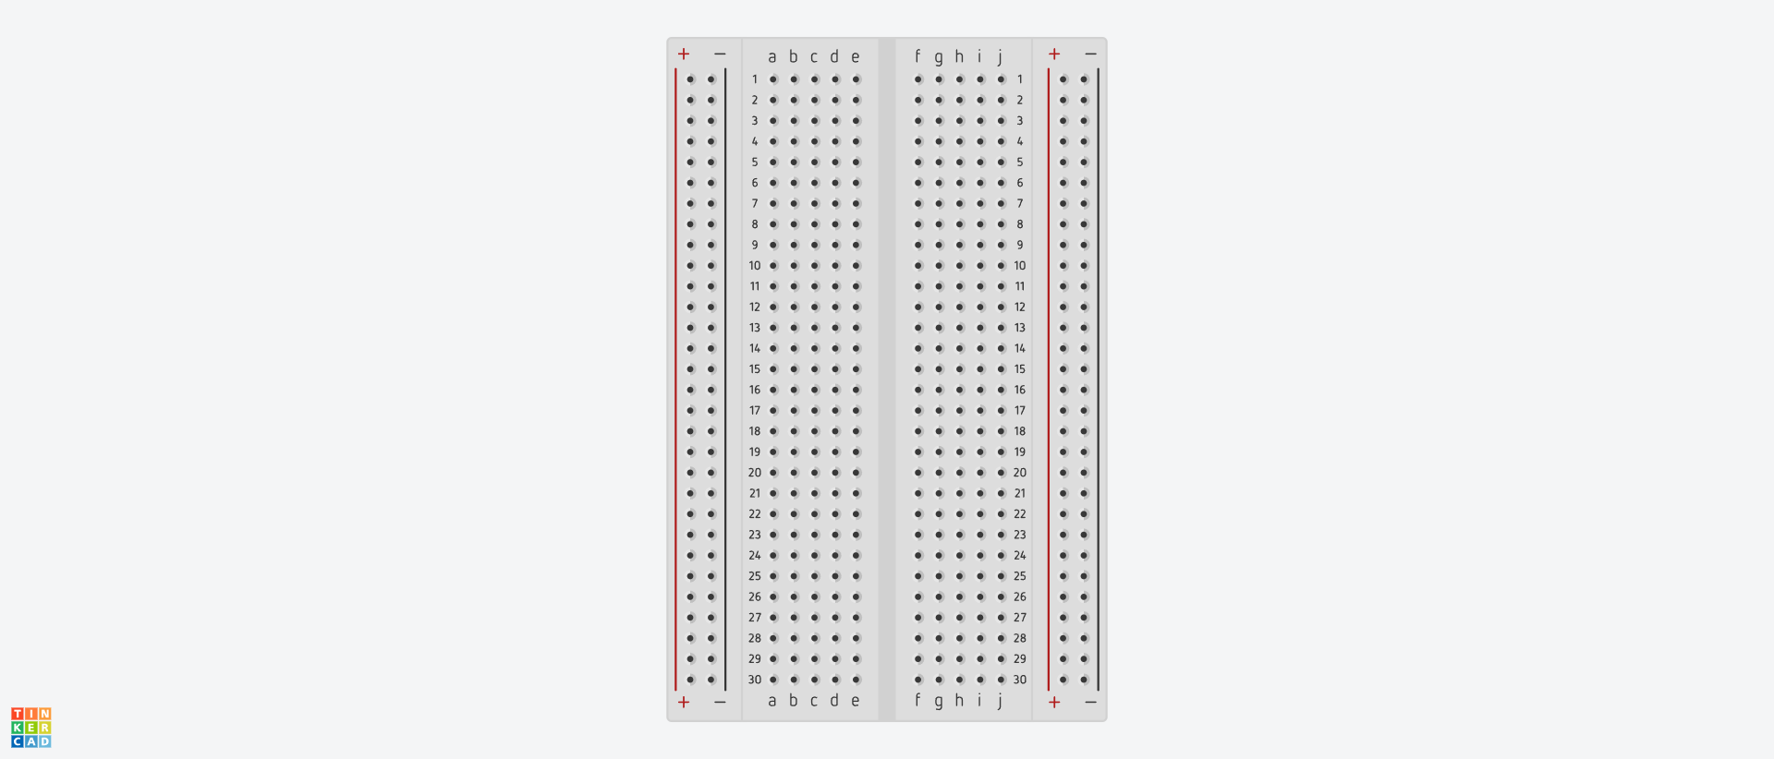  JOB: Creates temporary electrical nodes without soldering.  TEST / CHECK: Continuity-test a five-hole terminal group and each power rail. | Fixed resistor  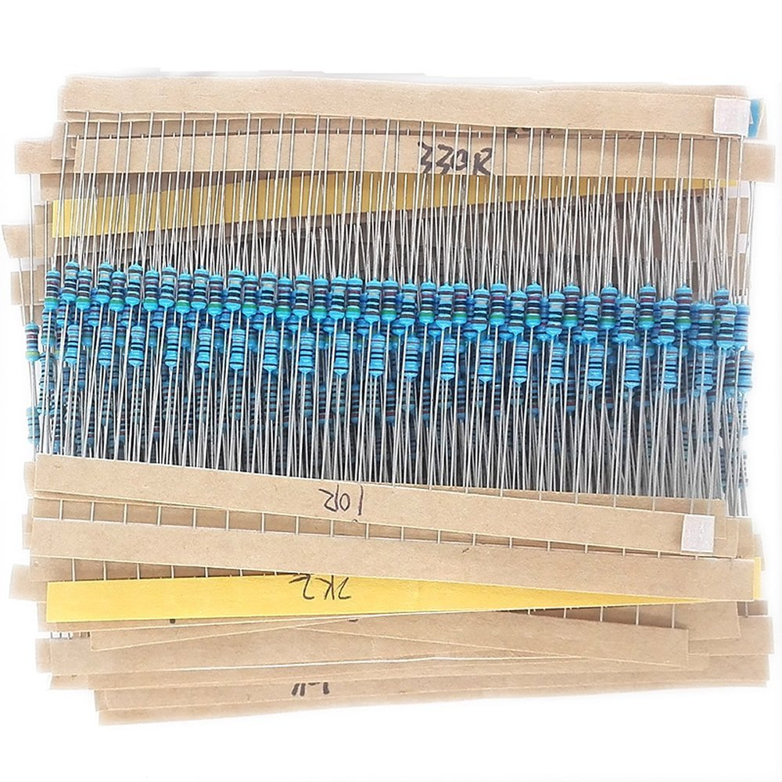  JOB: Limits current or produces a planned voltage drop.  TEST / CHECK: Read the color bands, then verify resistance with power off.  VEHICLE LINK: Blower resistors and sensor pull-up networks.
LED  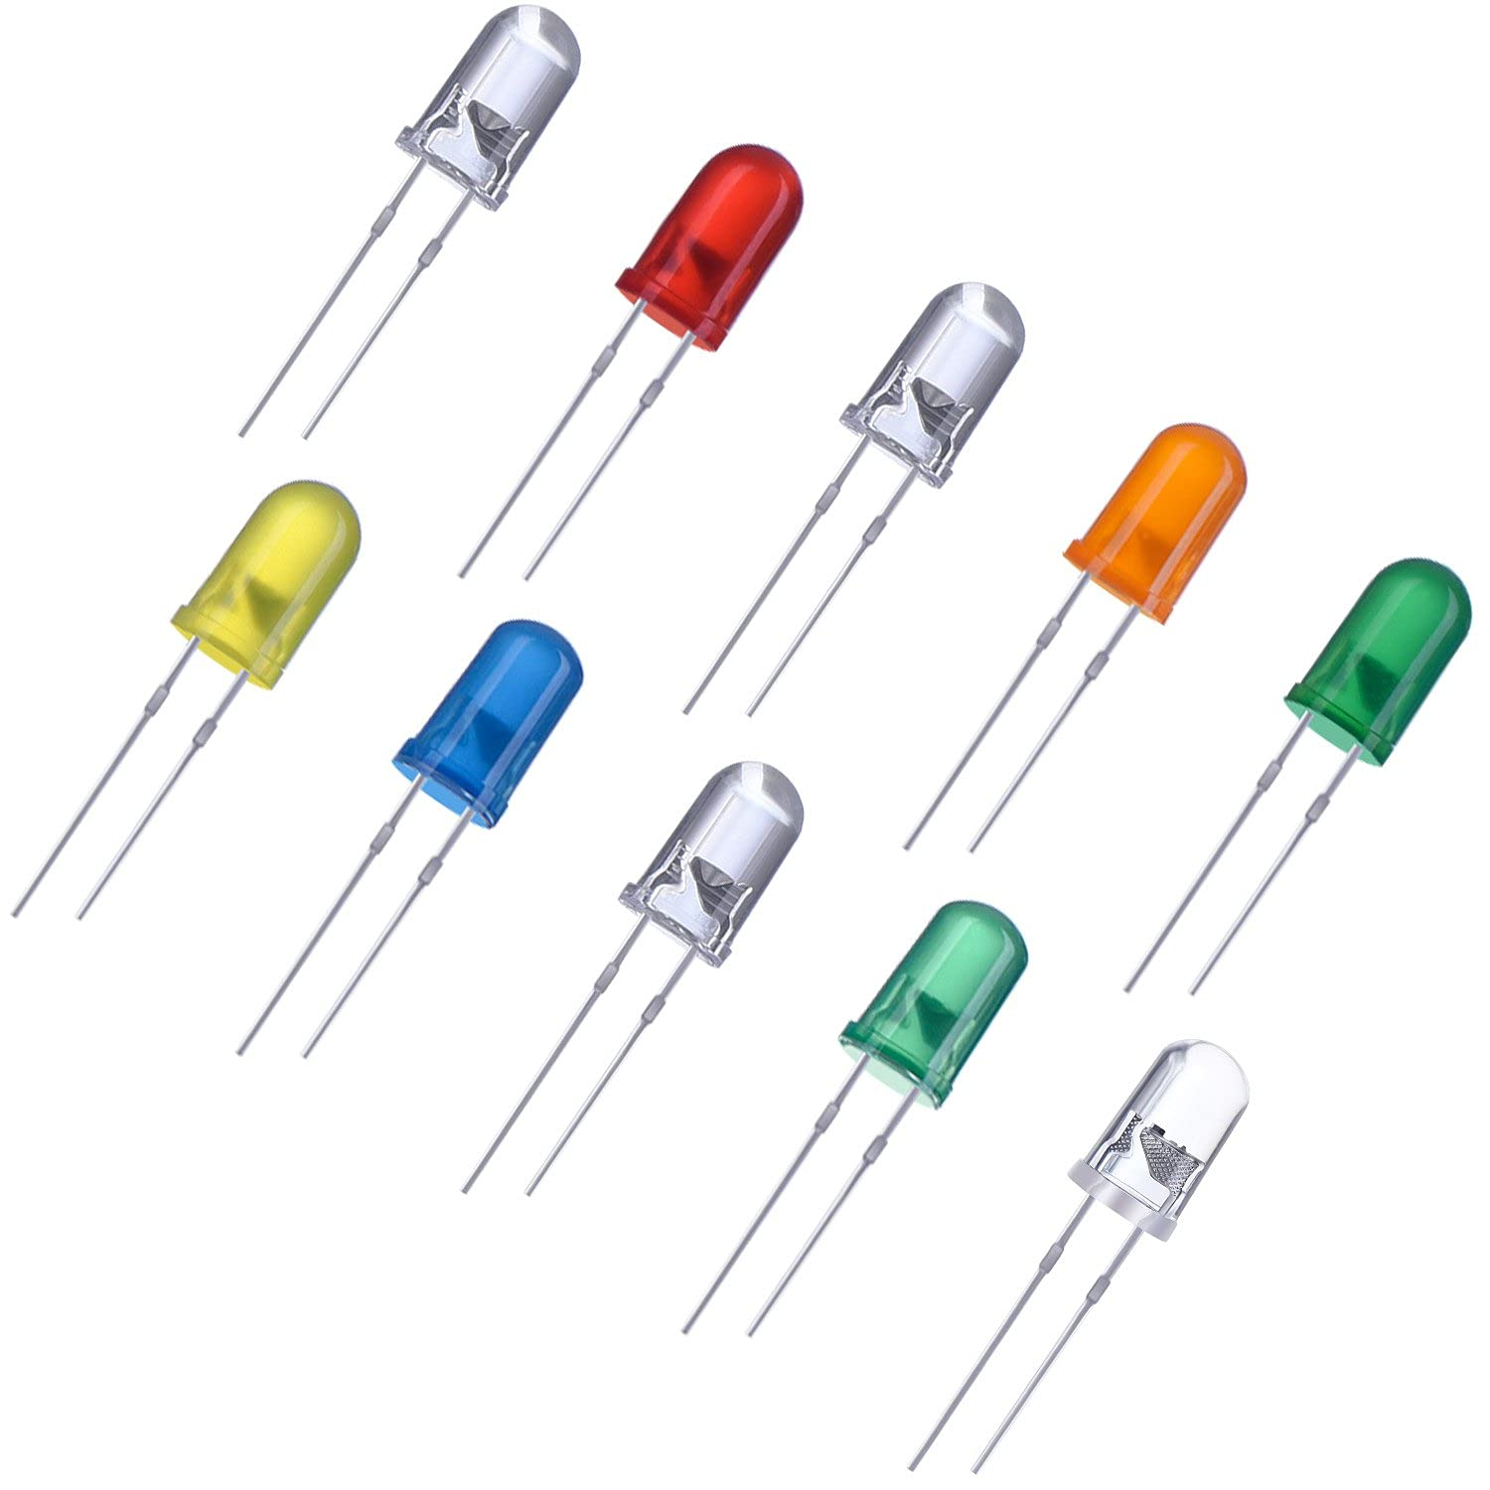  JOB: Produces light when forward biased.  TEST / CHECK: Identify anode/cathode; verify a series resistor is present.  VEHICLE LINK: Indicators, lighting, and displays. | 9 V connector + jumpers  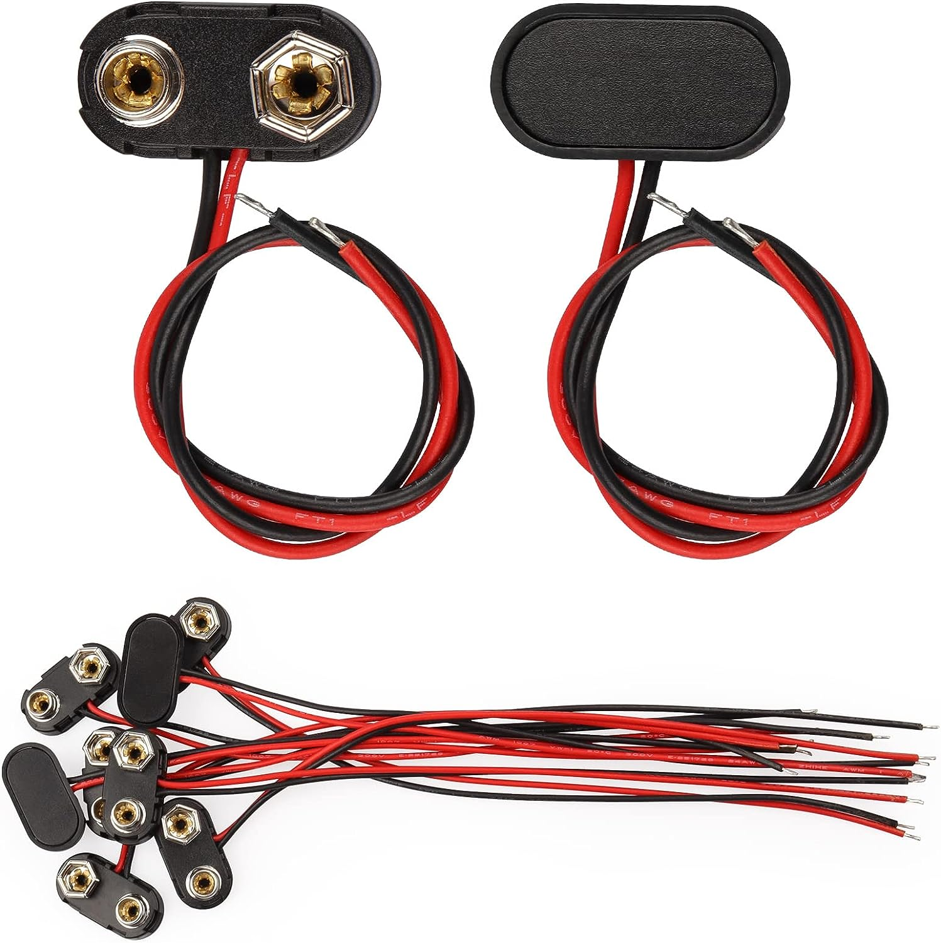  JOB: Carries source power and connects circuit nodes.  TEST / CHECK: Verify connector polarity and measure source voltage before use.
LED SIZING For a 9 V source and a typical red LED, 470 Ω is a safer starting value than 220 Ω. Estimate resistance with R = (Vsource − VLED) / ILED.

REFERENCE 2

Sensors, Controls, and Energy Storage
Thermistor  JOB: Changes resistance with temperature.  TEST / CHECK: Measure resistance, warm the part gently, and note the direction of change.  VEHICLE LINK: Coolant and intake-air temperature sensing. | Photoresistor (LDR)  JOB: Changes resistance with light intensity.  TEST / CHECK: Compare resistance in bright light and when covered.  VEHICLE LINK: Automatic headlamp concepts.
Potentiometer  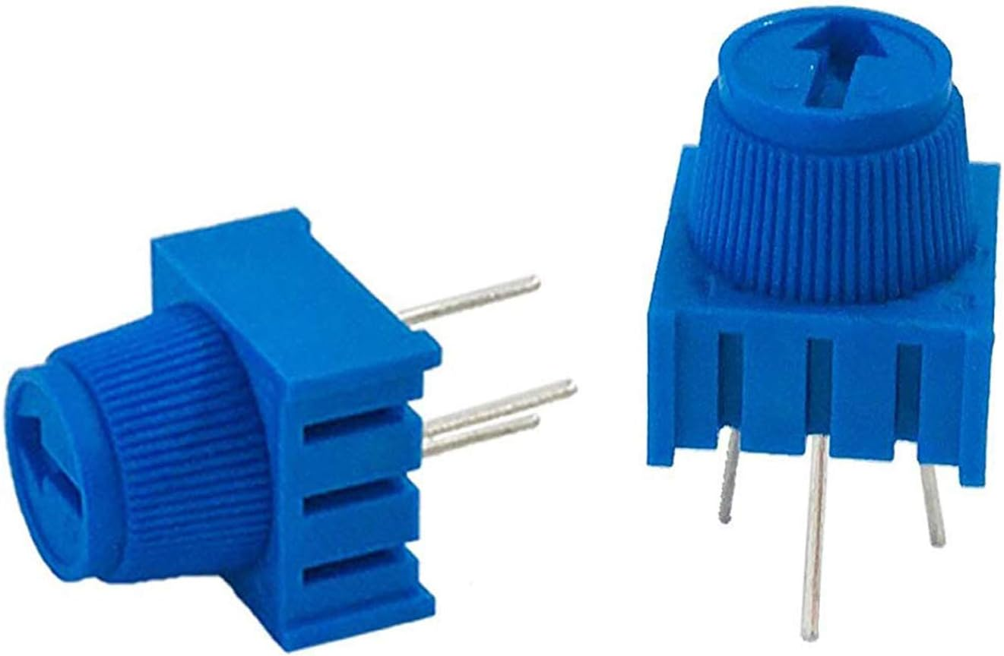  JOB: Uses a movable wiper to vary resistance or signal voltage.  TEST / CHECK: Find the two ends and the wiper; measure while rotating.  VEHICLE LINK: Position and level sensing. | Buzzer  JOB: Converts electrical energy into sound.  TEST / CHECK: Determine whether it is active (DC) or passive (pulsed signal).
RGB LED  JOB: Combines red, green, and blue LED elements.  TEST / CHECK: Identify common-anode or common-cathode and all four leads. | Capacitor  JOB: Stores charge for filtering, timing, or noise control.  TEST / CHECK: Identify capacitance; verify polarity on electrolytic types.  VEHICLE LINK: Module power filtering and signal conditioning.
INPUT | SENSING / CONTROL PART | ELECTRICAL RESPONSE
Temperature | Thermistor | Resistance changes
Light | LDR | Resistance changes
Position | Potentiometer | Resistance or signal voltage changes

REFERENCE 3

Semiconductors, Switching, and Polarity
NPN transistor  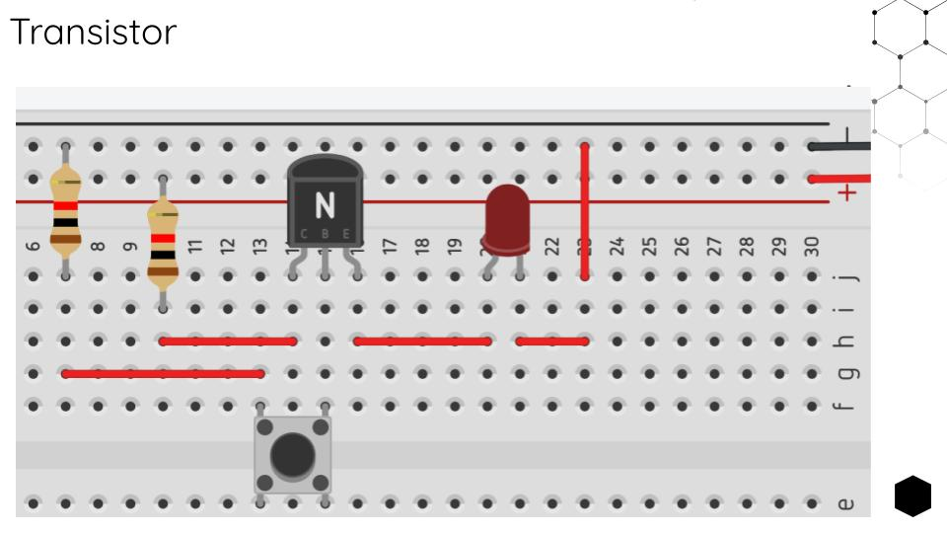  JOB: Uses a small base signal to switch a larger collector-emitter current.  TEST / CHECK: Confirm the exact emitter-base-collector pin order before wiring.  VEHICLE LINK: Lamp, relay, solenoid, and motor drivers. | Diode  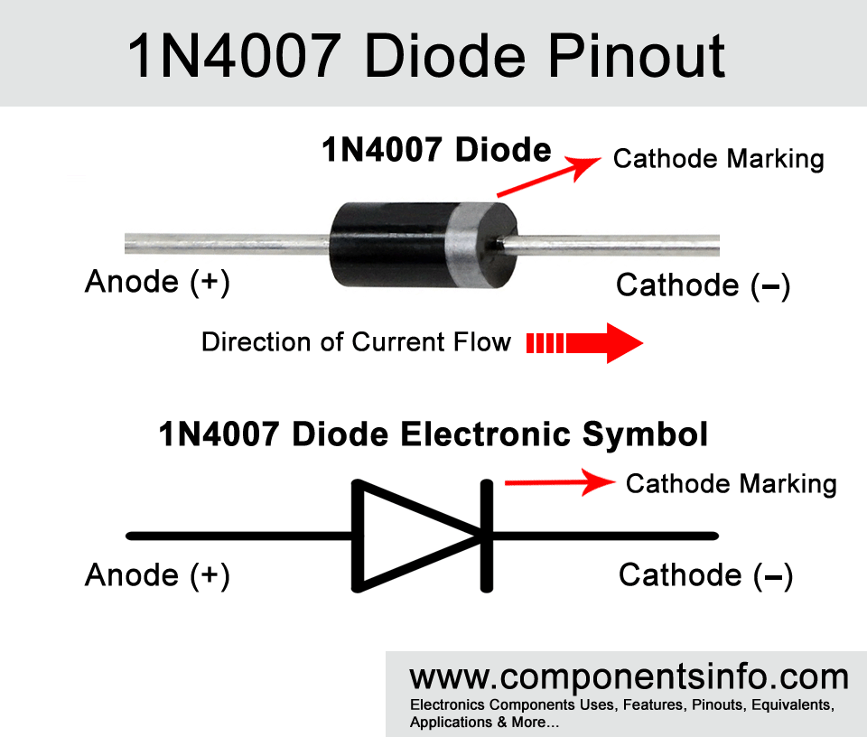  JOB: Conducts conventional current mainly in one direction.  TEST / CHECK: Band = cathode; compare diode-test readings in both directions.  VEHICLE LINK: Flyback and reverse-polarity protection.
Tactile pushbutton  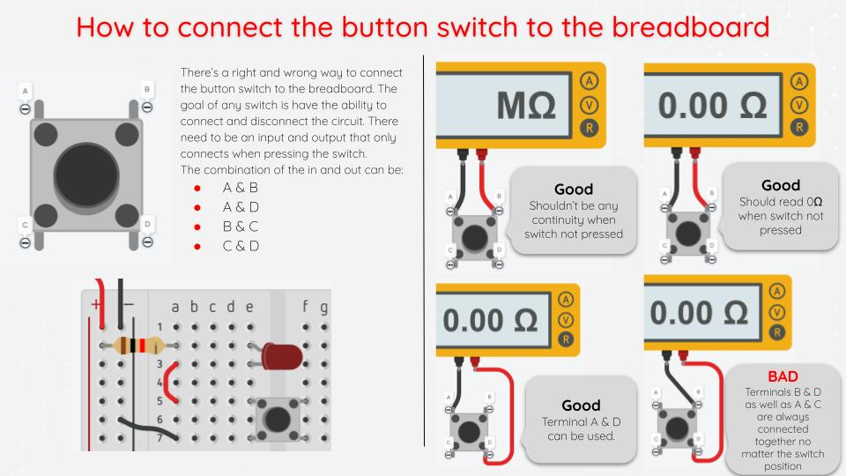  JOB: Opens or closes a signal path when pressed.  TEST / CHECK: Same-side pins stay common; opposite sides switch open to closed. | Electrolytic capacitor  JOB: Provides larger capacitance in a polarized package.  TEST / CHECK: Match the negative stripe and lead polarity to the circuit.
PINOUT WARNING PN2222/2N2222 and BC547 packages may not share the same lead order. Read the exact part marking and use the matching pinout before applying power.

CHECK POINT | EXPECTED | MEASURED | PASS / FIX
Diode forward direction | One junction drop | ________ | ________
Diode reverse direction | OL | ________ | ________
Switch across opposite sides | OL → about 0 Ω | ________ | ________

BREADBOARD FUNDAMENTALS

Read the Hidden Connections
A breadboard is a map of nodes. Your job is to know which holes share metal underneath.
Terminal strips + center trench  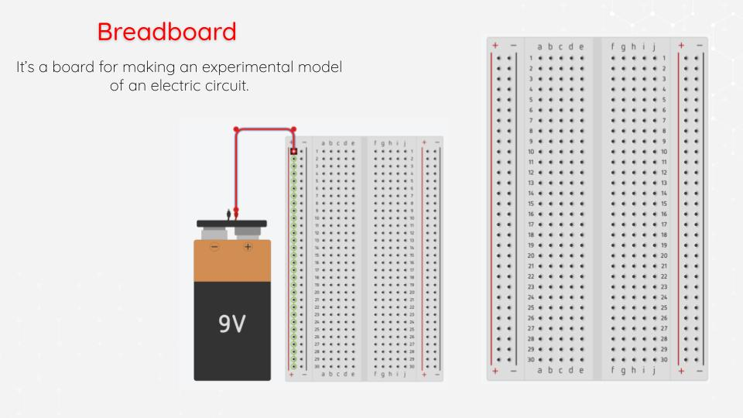  Groups of five are connected; the center trench separates the two sides. | Power + ground rails  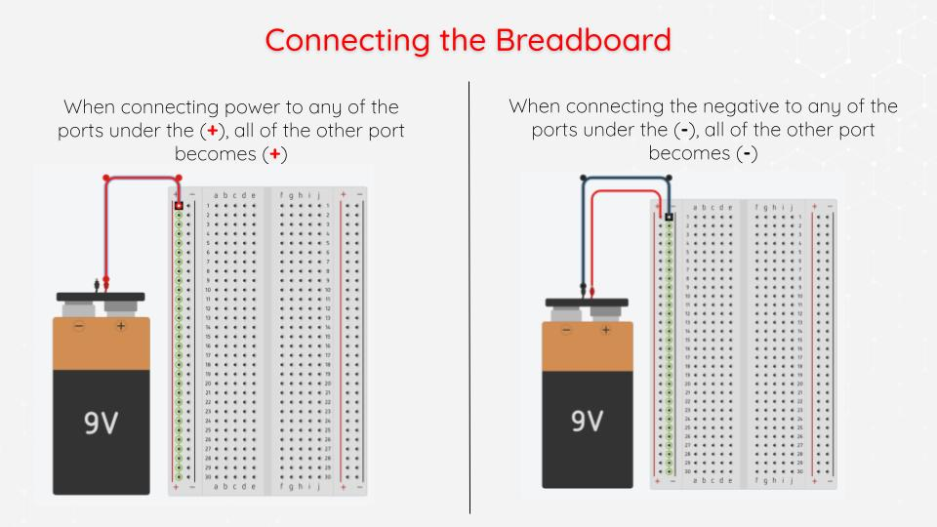  Red is normally positive and black is normally negative.

Four rules that prevent most breadboard faults
- Holes a–e share one terminal-strip node; holes f–j share a separate node.
- The center trench prevents the two sides from being connected.
- Some power rails split at the midpoint—verify continuity before assuming a full-length rail.
- Two leads placed in the same five-hole group are electrically connected, even without a jumper.
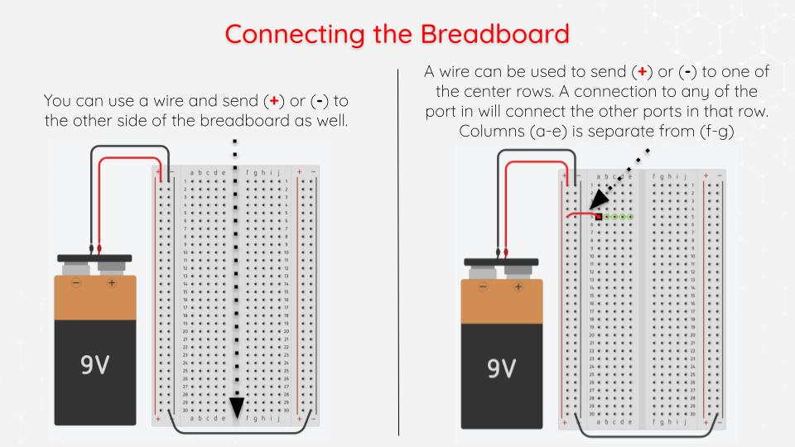
Bridge a split rail with a jumper only after continuity testing confirms the break.
TRACE IT  Circle one five-hole node on the image and describe what is connected.  ________________________________________  ________________________________________ | FAULT PREDICTION  What happens if both LED leads are placed in the same node?  ________________________________________  ________________________________________

BREADBOARD FUNDAMENTALS

Pre-Power Inspection + Circuit Logic
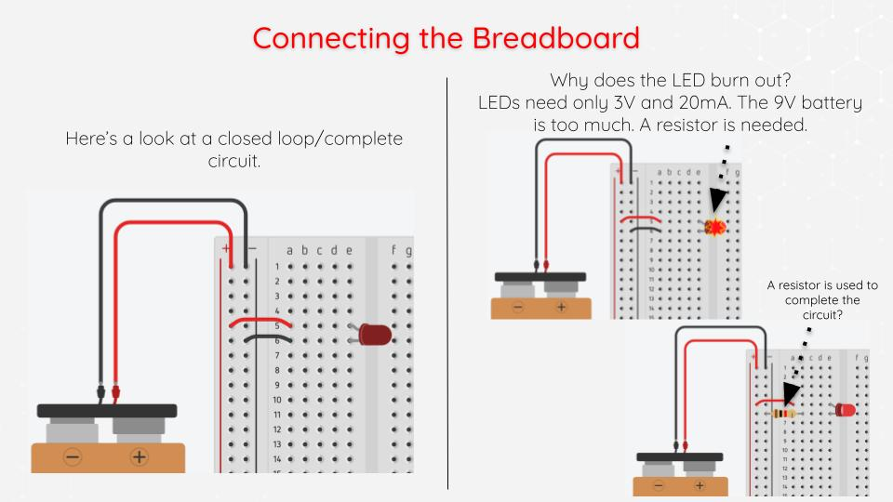
A complete circuit needs a source, a path through the load, and a return path. The series resistor protects the LED.

Use this order before every powered test
- POWER OFF — inspect for a direct B+ to ground short.
- TRACE — follow the full current path from B+ through each device to ground.
- POLARITY — confirm the LED, diode, capacitor, and transistor orientation.
- PROTECTION — confirm the LED resistor is truly in series.
- POWER ON — measure source voltage, then move through the circuit one node at a time.
DIAGNOSTIC HABIT Start with the source and ground. Then divide the circuit into smaller sections. A voltage measurement tells you where electrical potential exists; it does not by itself prove current is flowing.

INSTRUCTOR PRE-POWER STANDARD  ________________________________________ | STUDENT TRACES B+ → LOAD → GROUND  ________________________________________

LAB 1

Three Basic Circuit Types
Build series, parallel, and series-parallel examples and explain how the paths differ.
TIME 35–45 min | LEVEL FOUNDATION | PARTS Breadboard, LEDs, resistors, jumpers, 9 V source

1 PREDICT | 2 BUILD | 3 MEASURE | 4 EXPLAIN

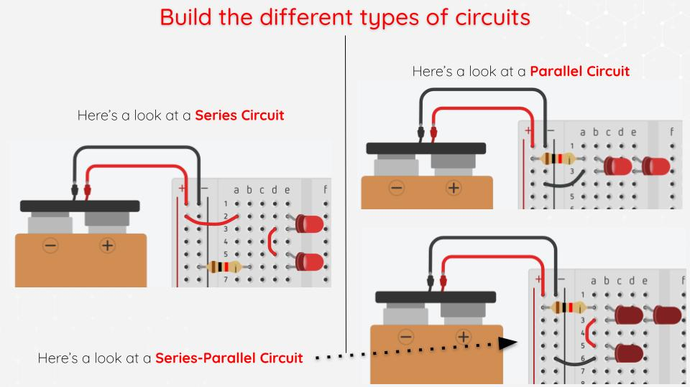
Trace each complete path before connecting the source.
CIRCUIT | PREDICT: PATHS | OBSERVED BRIGHTNESS / VOLTAGE | EXPLAIN
Series | ________ | ________________________ | ________________
Parallel | ________ | ________________________ | ________________
Series-parallel | ________ | ________________________ | ________________

DIAGNOSE  One open load stops every load in which circuit type? Why?  ________________________________________  ________________________________________ | EXPLAIN  Why is branch voltage the same in a parallel circuit?  ________________________________________  ________________________________________
THREE BUILDS VERIFIED  ________________________________________ | STUDENT TRACES EVERY CURRENT PATH  ________________________________________

LAB 2

Tactile Switch Continuity
Use resistance evidence to identify the correct switching pair before placing the switch in a powered circuit.
TIME 25–35 min | LEVEL FOUNDATION | PARTS Tactile switch, DMM, breadboard, jumpers

1 PREDICT | 2 BUILD | 3 MEASURE | 4 EXPLAIN

The two pins on the same side are internally common. Use opposite sides for switching.
METER CONNECTION | RELEASED | PRESSED | WHAT THIS PROVES
Across opposite sides | ________ | ________ | ________________________
Across same side | ________ | ________ | ________________________

BUILD RULE Place the tactile switch across the breadboard center trench so the two common sides occupy separate terminal strips.

PREDICT  Which pin pair should change from OL to about 0 Ω?  ________________________________________  ________________________________________ | DIAGNOSE  Why does the wrong pair stay near 0 Ω in both states?  ________________________________________  ________________________________________
METER SETUP VERIFIED  ________________________________________ | CORRECT SWITCHING PAIR IDENTIFIED  ________________________________________

LAB 3

First LED Circuit
Build a protected LED circuit, prove the complete path, and diagnose it if the LED stays off.
TIME 30–40 min | LEVEL FOUNDATION | PARTS LED, 470 Ω resistor, breadboard, jumpers, 9 V source, DMM

1 PREDICT | 2 BUILD | 3 MEASURE | 4 EXPLAIN

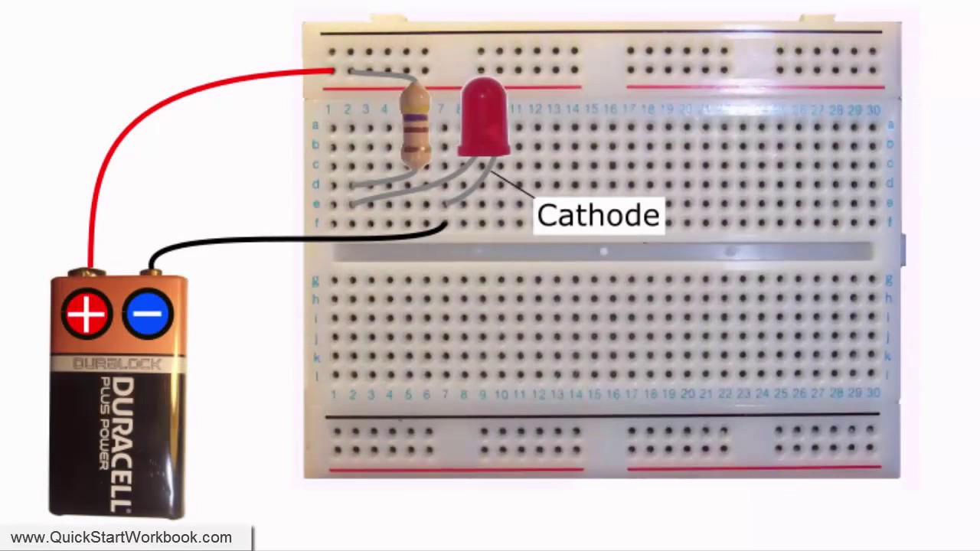
The resistor and LED must be in series. The flat edge / shorter lead normally identifies the cathode.
- With power disconnected, connect the positive and negative rails.
- Install a 470 Ω resistor from B+ to a new terminal-strip node.
- Connect the LED anode to the resistor output and the cathode to a separate node.
- Complete the return path from the cathode node to ground.
- Trace, inspect, receive the pre-power check, then connect the source.
CHECK POINT | EXPECTED | MEASURED | PASS / FIX
Battery | About 9 V | ________ V | ________
LED anode to cathode | Color-dependent drop | ________ V | ________
Ground path | Near 0 Ω, power off | ________ Ω | ________

IF THE LED STAYS OFF Check source voltage, rail continuity, LED polarity, resistor continuity, and the ground-side connection—in that order.

LAB 4

LED Forward Voltage
Compare predicted and measured forward voltage for several LED colors.
TIME 30–40 min | LEVEL MEASUREMENT | PARTS Colored LEDs, 470 Ω resistor, breadboard, 9 V source, DMM

1 PREDICT | 2 BUILD | 3 MEASURE | 4 EXPLAIN

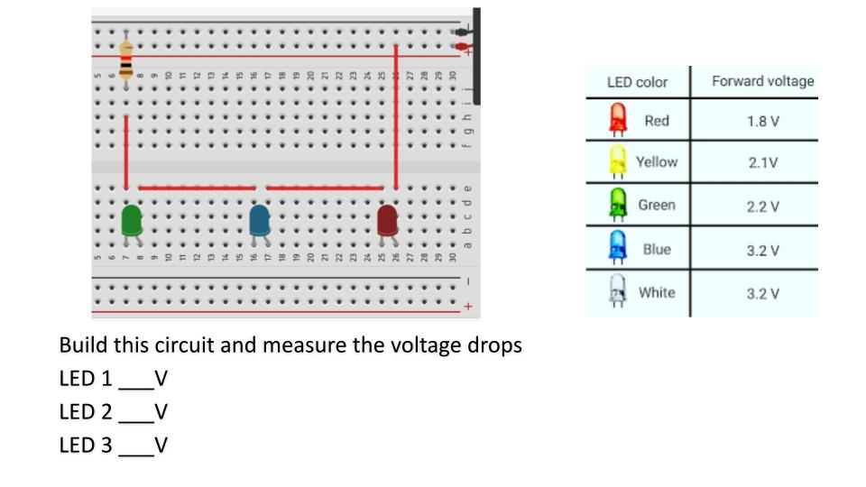
Place the voltmeter directly across the illuminated LED while the circuit is powered.
COLOR | TYPICAL RANGE | PREDICT | MEASURED | DIFFERENCE
Red | 1.8–2.2 V | _____ V | _____ V | _____ V
Yellow | 2.0–2.3 V | _____ V | _____ V | _____ V
Green | 2.0–3.2 V | _____ V | _____ V | _____ V
Blue | 2.8–3.4 V | _____ V | _____ V | _____ V
White | 2.8–3.4 V | _____ V | _____ V | _____ V

INTERPRET THE RANGE LED chemistry, current, and temperature affect forward voltage. A typical range is a comparison tool, not an exact specification.

EVIDENCE  Which color produced the highest measured drop?  ________________________________________  ________________________________________ | EXPLAIN  How would a higher LED drop affect resistor voltage in this series circuit?  ________________________________________  ________________________________________

LAB 5

RGB LED Control
Identify the common lead, control each color independently, and document additive color mixing.
TIME 40–50 min | LEVEL INTERMEDIATE | PARTS RGB LED, 3 switches, 3 resistors, breadboard, jumpers, 9 V source

1 PREDICT | 2 BUILD | 3 MEASURE | 4 EXPLAIN

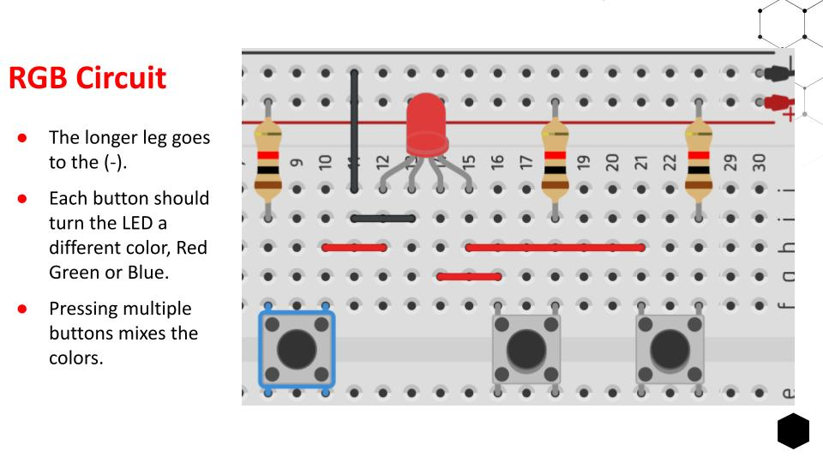
Each internal LED requires its own current-limiting resistor.
RED | GREEN | BLUE | PREDICTED COLOR | OBSERVED COLOR
ON | OFF | OFF | Red | ________
OFF | ON | OFF | Green | ________
OFF | OFF | ON | Blue | ________
ON | ON | OFF | Yellow | ________
ON | OFF | ON | Magenta | ________
OFF | ON | ON | Cyan | ________
ON | ON | ON | Near white | ________

VERIFY FIRST Identify common-anode versus common-cathode and the four-lead order before power is applied. Do not assume every RGB LED shares the diagram's pinout.

DIAGNOSE  One color never lights. List two checks that isolate the fault.  ________________________________________  ________________________________________ | EXPLAIN  Why does every color channel need its own resistor?  ________________________________________  ________________________________________

LAB 6

Potentiometer LED Dimmer
Relate wiper position, resistance, LED voltage, and brightness.
TIME 40–50 min | LEVEL INTERMEDIATE | PARTS Potentiometer, LED(s), resistor(s), breadboard, 9 V source, DMM

1 PREDICT | 2 BUILD | 3 MEASURE | 4 EXPLAIN

Single-LED dimmer  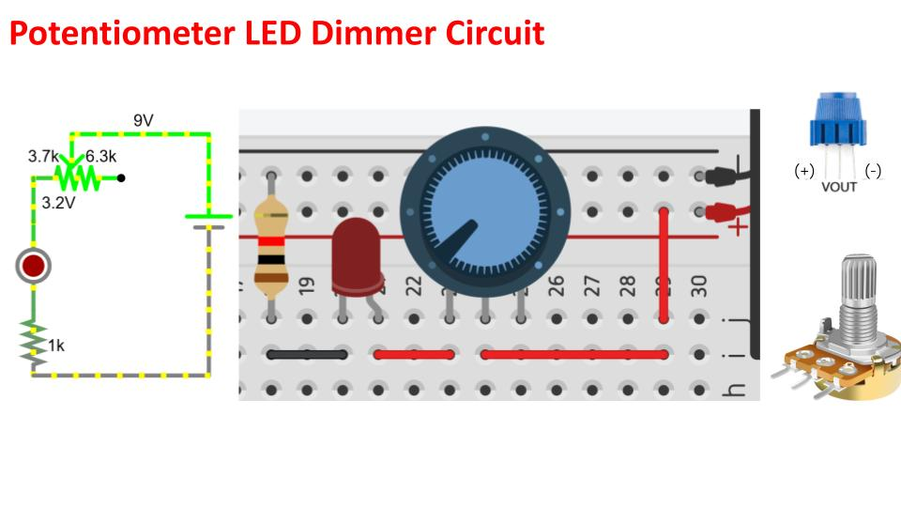  Changing resistance changes LED current. | Dual-LED variation  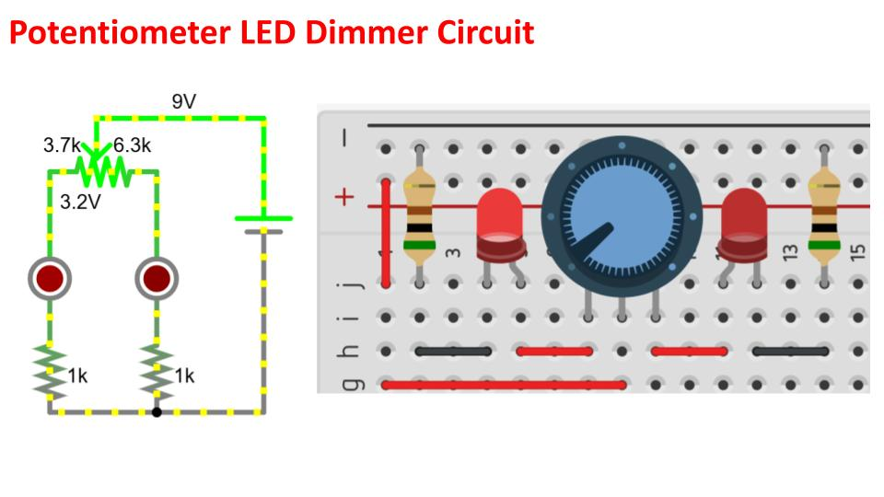  One LED can brighten while the other dims.
KNOB POSITION | WIPER RESISTANCE | LED VOLTAGE | BRIGHTNESS
Minimum | ________ Ω | ________ V | ________
Midpoint | ________ Ω | ________ V | ________
Maximum | ________ Ω | ________ V | ________

PROTECT THE CIRCUIT Keep a fixed series resistor in the LED path so a zero-ohm potentiometer position cannot overcurrent the LED. Do not exceed the potentiometer power rating.

GRAPH IN WORDS  Describe the relationship between resistance and brightness.  ________________________________________  ________________________________________ | DIAGNOSE  The LED never gets bright. Which three measurements would you take?  ________________________________________  ________________________________________
THREE POSITIONS MEASURED  ________________________________________ | STUDENT EXPLAINS THE WIPER  ________________________________________

LAB 7

Transistor Switch + Automatic Night Light
Use a low-current sensor network to control a separate LED load.
TIME 45–60 min | LEVEL ADVANCED | PARTS NPN transistor, LDR, resistors, LED, breadboard, 9 V source, DMM

1 PREDICT | 2 BUILD | 3 MEASURE | 4 EXPLAIN

NPN transistor switch  A small base signal controls collector-emitter current. | Automatic night-light  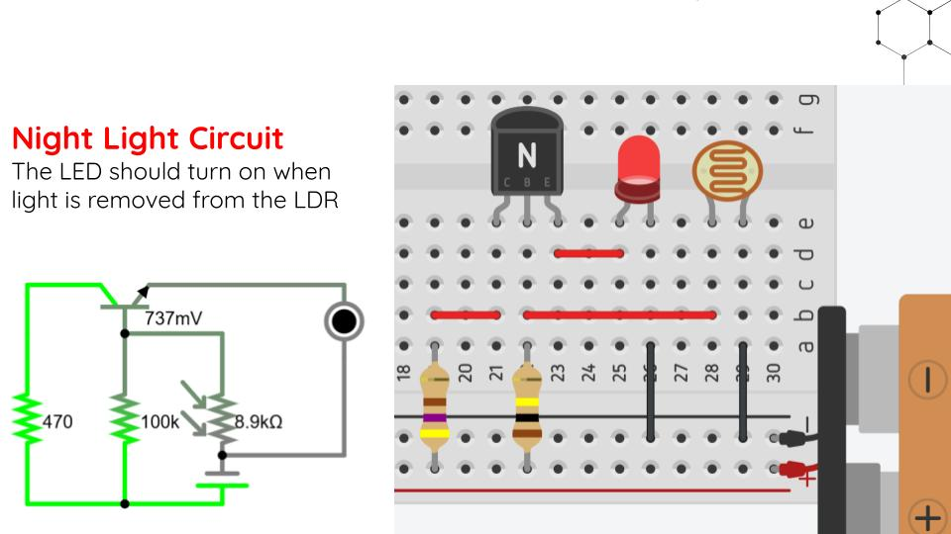  Covering the LDR changes the transistor input.
LIGHT CONDITION | LDR RESISTANCE | BASE VOLTAGE | LED STATE
Bright | ________ Ω | ________ V | ________
Covered / dark | ________ Ω | ________ V | ________

PINOUT WARNING Identify emitter, base, and collector using the exact transistor marking. PN2222/2N2222 and BC547 packages may use different lead orders.

SIGNAL MAP  Identify INPUT → CONTROL DEVICE → OUTPUT.  ________________________________________  ________________________________________ | DIAGNOSE  LED stays on in bright light. Name two likely causes.  ________________________________________  ________________________________________
LIGHT / DARK OPERATION VERIFIED  ________________________________________ | STUDENT EXPLAINS TRANSISTOR SWITCHING  ________________________________________

PRACTICAL ASSESSMENT

Choose → Design → Build → Prove
Select one challenge, obtain approval, and document enough evidence that another student could reproduce your result.
Dual pushbutton LEDs  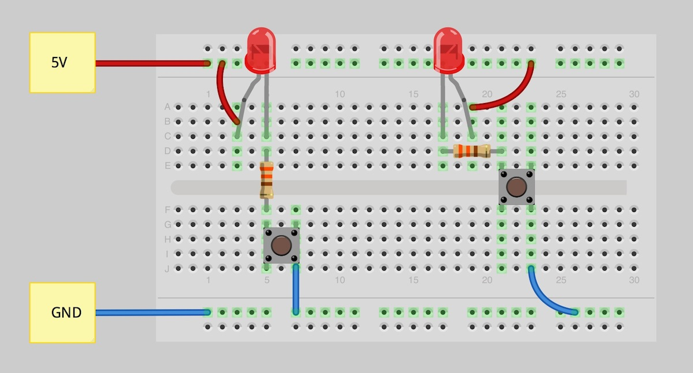  Approval: __________ | LDR night-light prototype  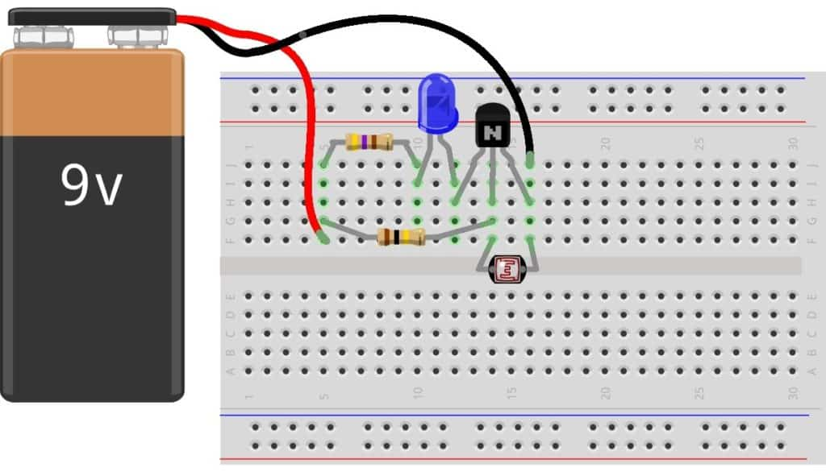  Approval: __________
Dual-transistor prototype  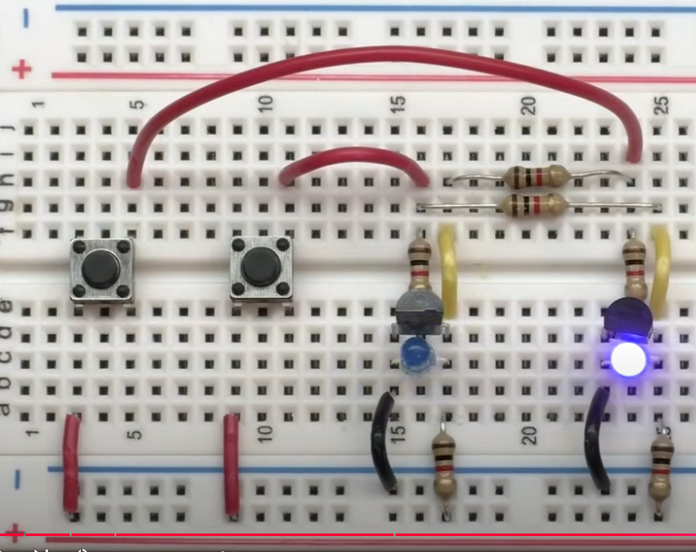  Approval: __________ | Zener voltage ladder  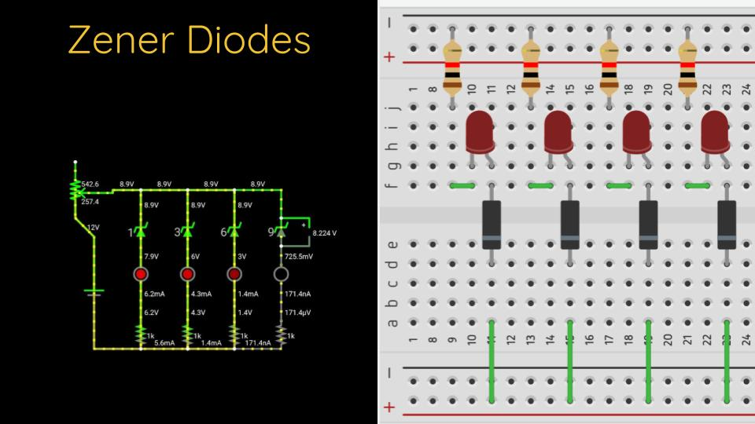  Approval: __________
SKILL | EVIDENCE REQUIRED | SCORE
Identify | Names components, terminals, and polarity correctly | __/4
Build | Creates a safe, complete, organized current path | __/4
Measure | Selects meter function and records useful evidence | __/4
Diagnose | Isolates one inserted or naturally occurring fault | __/4
Explain | Connects input, control, output, and result | __/4

PREDICTION  What should the circuit do before you build it?  ________________________________________  ________________________________________ | DIAGNOSTIC PROOF  Record one fault, one measurement, and the fix.  ________________________________________  ________________________________________
FINAL DEMONSTRATION  ________________________________________ | TOTAL SCORE: ______ / 20  ________________________________________

APPENDIX A

Kit Component Identification Reference
Use this manufacturer image as a visual starting point; verify the exact markings and values on the parts in your own kit.
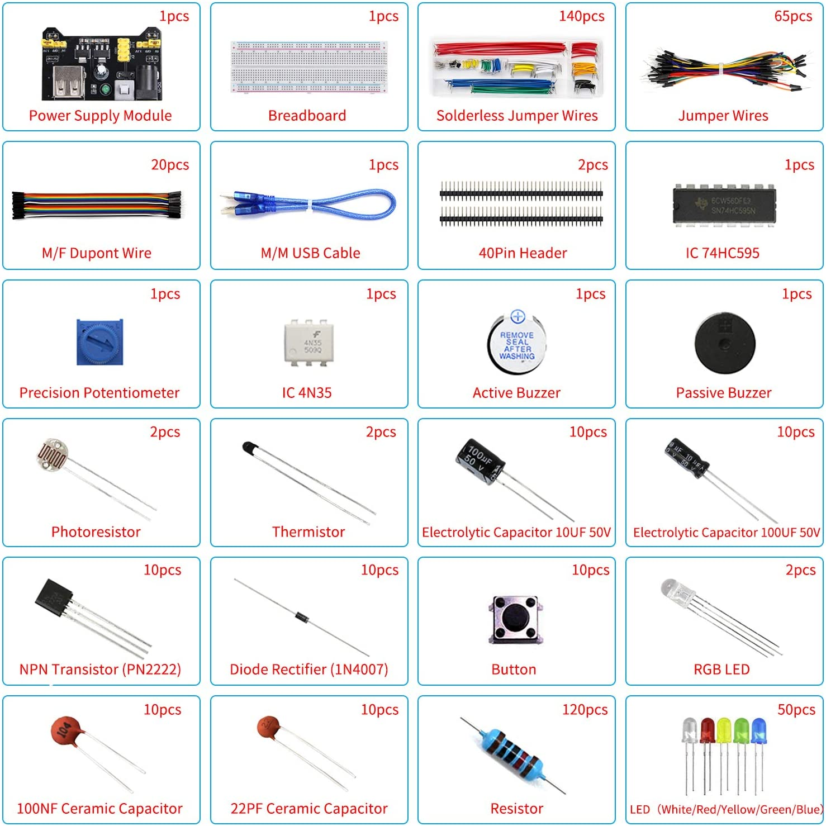
Manufacturer identification image included in the original packet.
PART TO RECHECK | IDENTIFICATION EVIDENCE | INSTRUCTOR
________________ | ________________________________________ | ________
________________ | ________________________________________ | ________
________________ | ________________________________________ | ________

FINAL REMINDER Appearance is only the first clue. Use part markings, polarity indicators, resistance, diode-test behavior, continuity, and the exact pinout to confirm identification.

