STUDENT LAB WORKSHEET
Ohm's Law: Make the Circuit Prove It
Predict • Build • Measure • Explain
DURATION  3–4 HOURS | TEAM  2 STUDENTS | INVESTIGATIONS  4 | TOTAL  100 POINTS

NAME |  | PARTNER
DATE |  | CLASS / BLOCK

MISSION Use a digital multimeter and a working DC circuit to gather evidence that current changes predictably when voltage or resistance changes.

Learning Targets
□ Select and rearrange the correct Ohm's law equation. | □ Build a simple DC circuit and verify it before energizing.
□ Measure voltage, current, and resistance correctly. | □ Compare predicted and measured values using evidence.

Formula & Unit Card
FIND VOLTAGE  V = I × R  volts (V) | FIND CURRENT  I = V ÷ R  amperes (A) | FIND RESISTANCE  R = V ÷ I  ohms (Ω)
mA → A: divide by 1,000 | A → mA: multiply by 1,000 | % error = |measured − predicted| ÷ predicted × 100

Safety & Quality Gate
□ | Power OFF before measuring resistance or moving meter leads.
□ | Ammeter connects in series; voltmeter connects in parallel.
□ | Never place the ammeter directly across a battery or power source.
□ | Begin on a safe current range and verify the correct meter jack.
□ | Use the instructor-assigned supply and load; do not exceed ratings.
□ | Open the switch between tests and ask for an inspection before power.
Student initials: ________________ Instructor safety approval: ________________

LAB 1 | Meter & Resistor Reality Check
Prove your meter setup and component values before energizing a circuit.
MATERIALS DMM, jumper wires, knife switch, battery holder or 0–5 V supply, four assigned resistors, and safety glasses as directed.

A. Quick Readiness Check
1. Write the unit for each quantity: voltage = ______; current = ______; resistance = ______.
2. A 4.5 V source is connected to 330 Ω. Predict current in amperes and milliamperes.
3. If voltage doubles while resistance stays constant, current will ____________________.
4. If resistance doubles while voltage stays constant, current will ____________________.
5. Circle the correct rule: resistance is measured with power ON / OFF.

B. Correct Meter Placement
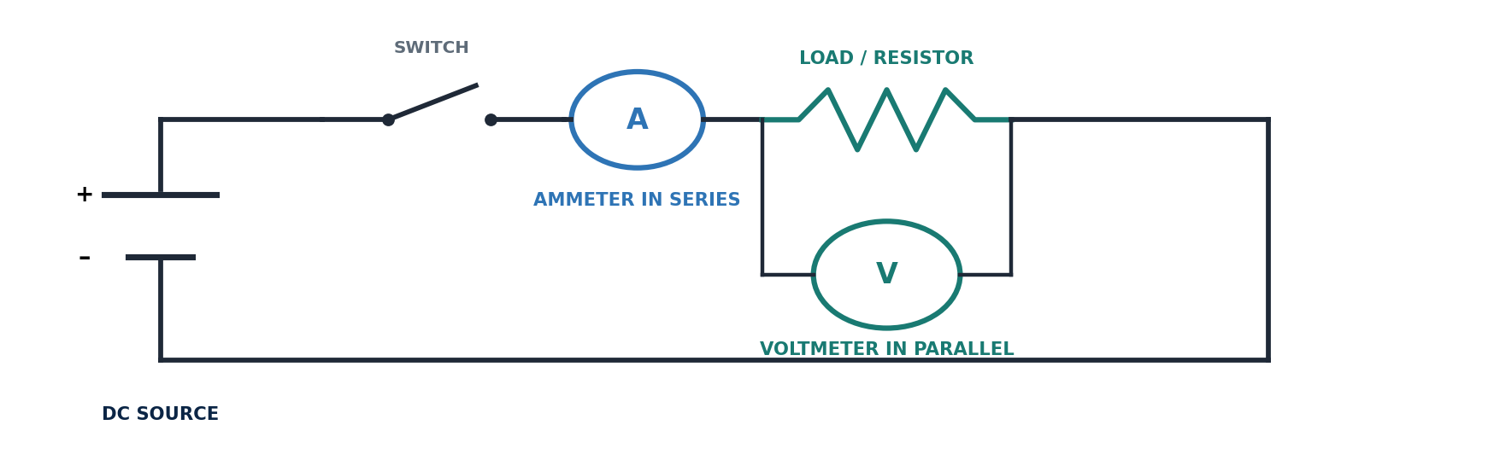
If only one DMM is available, de-energize the circuit before changing the meter mode, jack, or connection.
METER LEADS | COM + correct V/Ω or A/mA jack | APPROVAL | Instructor initials: ____________

C. Resistor Verification — Power OFF
Identify four assigned resistors, calculate each acceptable tolerance range, then compare the DMM reading with the labeled value.
ID | Color Bands /  Label | Nominal  R (Ω) | Tolerance  (%) | Min–Max  Acceptable (Ω) | Measured  R (Ω) | Pass?  Y / N
A
B
C
D
Tolerance formula: minimum = nominal × (1 − tolerance); maximum = nominal × (1 + tolerance)
EVIDENCE 1. Which resistor was closest to its nominal value? Support your answer with numbers.

EVIDENCE 2. Why can a good resistor measure slightly above or below its labeled value?

LAB 2 | Voltage Drives Current
Change voltage while keeping resistance constant. Record the effect on current.
CONTROLLED VARIABLE Use the same resistor for every trial. Recommended: 330 Ω, ¼ W. Record your measured resistor value below.

RESISTOR USED | Nominal: ______ Ω | Measured: ______ Ω | VOLTAGE LEVELS | 1.5 V, 3.0 V, and 4.5 V

Build & Test
- Open the switch. Build a series path: source → switch → resistor → ammeter → source.
- Connect the voltmeter in parallel across the resistor. If using one DMM, take voltage and current readings separately with power OFF between changes.
- Set the source to 1.5 V. Measure actual voltage. Calculate predicted current before closing the switch.
- Ask for inspection, close the switch briefly, record current, then open the switch.
- Repeat at 3.0 V and 4.5 V without changing the resistor.

Data Table
Trial | Source  Setting | Measured  V (V) | Measured  R (Ω) | Predicted  I (mA) | Measured  I (mA) | % Error
1 | 1.5 V
2 | 3.0 V
3 | 4.5 V

Show One Complete Calculation
Predicted current | I = V ÷ R = __________ V ÷ __________ Ω = __________ A = __________ mA
% error | |__________ − __________| ÷ __________ × 100 = __________ %

Graph & Explain
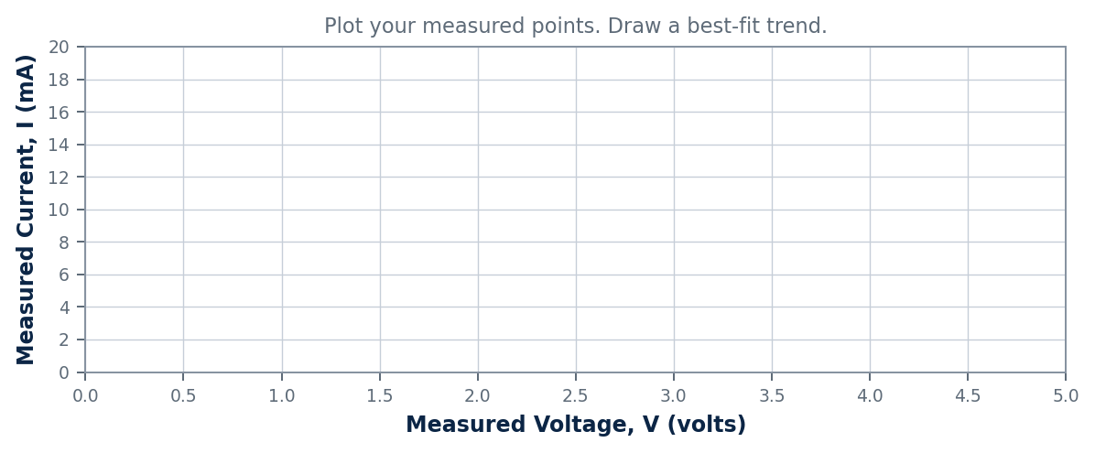
1. Relationship  Circle one: DIRECT / INVERSE / NO CLEAR PATTERN | 2. Evidence  When voltage increased from ______ V to ______ V, current changed from ______ mA to ______ mA.
3. Prediction  At 6.0 V with the same resistor, predicted current = __________ mA. | 4. Explanation  Describe why your measured values may not exactly match the calculated values.

LAB 3 | Resistance Controls Current
Hold voltage steady. Change resistance and observe how current responds.
FIXED SUPPLY Use 4.5 V (three AA cells or the instructor-set supply). Use only ¼ W or higher resistors: 220 Ω, 470 Ω, 680 Ω, and 1,000 Ω.

Build & Test
- Open the switch and install the 220 Ω resistor. Measure its actual resistance with power OFF.
- Calculate predicted current using the measured supply voltage and measured resistance.
- Inspect the meter mode and leads. Close the switch briefly, measure current, then open the switch.
- Repeat with 470 Ω, 680 Ω, and 1,000 Ω. Keep the supply voltage unchanged.
- Touch components only after power is removed. Report unusual heat immediately.

Data Table
Trial | Resistor  Label (Ω) | Measured  R (Ω) | Measured  V (V) | Predicted  I (mA) | Measured  I (mA) | % Error
1 | 220
2 | 470
3 | 680
4 | 1,000

Show One Complete Calculation
Predicted current | I = V ÷ R = __________ V ÷ __________ Ω = __________ A = __________ mA
Resistance check | R = V ÷ I = __________ V ÷ __________ A = __________ Ω

Graph & Explain
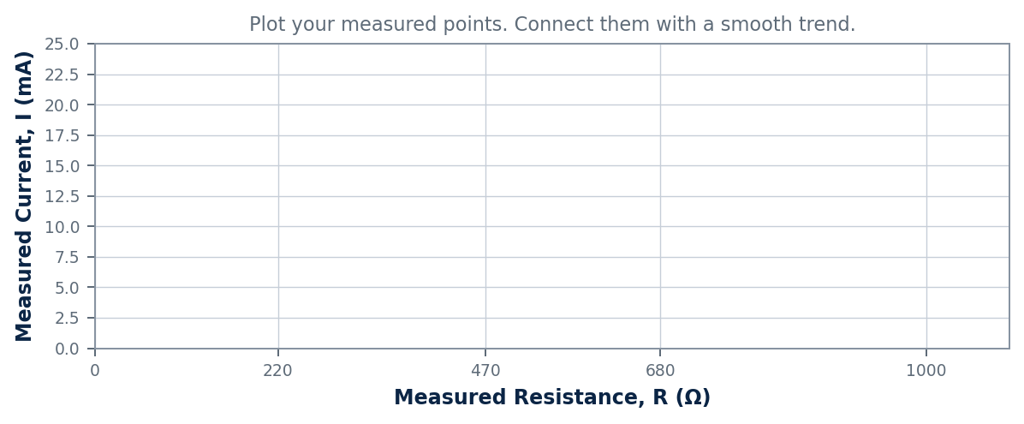
1. Relationship  Circle one: DIRECT / INVERSE / NO CLEAR PATTERN | 2. Rank  Largest current → smallest current: ______ Ω, ______ Ω, ______ Ω, ______ Ω
3. Pattern  When resistance increased, current ______________________________________. | 4. Automotive link  Added resistance from corrosion causes component current to __________ and performance to __________.

LAB 4 | The Miniature Lamp: A Changing Resistance
Compare a filament's resistance when it is cold and when it is operating.
CAUTION Use only the instructor-assigned bulb and supply. The bulb rating must match the test voltage. Open the switch if the lamp becomes unusually bright or hot.

A. Cold-Filament Check — Power OFF
BULB RATING  ________ V / ________ A  (if marked) | COLD RESISTANCE  R₍cold₎ = __________ Ω | METER MODE  Ω | Leads removed  from power source | TEAM CHECK  Partner verified  power OFF: □ Yes

B. Operating Test
- Build a series circuit with source → switch → lamp → ammeter → source.
- Connect the voltmeter in parallel across the lamp, or take voltage and current readings separately with power OFF between meter changes.
- Predict current using the cold resistance. Mark this prediction as an estimate only.
- Ask for inspection. Energize the lamp long enough to obtain a steady reading, then open the switch.
- Calculate the lamp's operating resistance and power from the measured values.
Supply  V (V) | Lamp  V (V) | Current  I (A) | Current  I (mA) | Calculated Hot  R = V ÷ I (Ω) | Lamp Power  P = V × I (W)

C. Calculation Workspace
Cold-current estimate | I = V ÷ R₍cold₎ = __________ V ÷ __________ Ω = __________ A = __________ mA
Hot resistance | R₍hot₎ = V ÷ I = __________ V ÷ __________ A = __________ Ω
Lamp power | P = V × I = __________ V × __________ A = __________ W

D. Compare & Explain
1. Compare values | R₍hot₎ was __________ times R₍cold₎. (R₍hot₎ ÷ R₍cold₎)
2. Choose the evidence | The filament's resistance: □ increased □ decreased □ stayed constant
3. Explain the physics | As the filament heated, its resistance ________________________, which caused current to ________________________.
CER. Write one claim, one measured piece of evidence, and one sentence of reasoning showing why an incandescent lamp is not a constant-resistance load.

CHALLENGE | Find the Fault
Use expected values, voltage checks, and power-off resistance checks to identify one hidden circuit fault.
FAULT BANK Instructor may install one safe fault: open connection, high-resistance connection, reduced source voltage, incorrect resistor, or loose connection. Do not create your own fault.

1. Establish the Normal Baseline
SOURCE Expected: ______ V  CURRENT Expected: ______ A or ______ mA | LOAD Component / value: __________________  OPERATION Expected behavior: ______________________ | CALCULATION I = V ÷ R = __________________  APPROVAL Baseline verified: □ Yes Initials: ______

2. Record the Symptom Before Touching the Circuit
OBSERVE. What is the circuit doing—or not doing? Be specific.

COMPARE. How does the symptom differ from the baseline?

3. Diagnostic Measurements
Check Point | Expected | Measured | Difference | What This Suggests
Source voltage
Voltage before load
Voltage across load
Voltage after load / ground side
Circuit current
Power-off resistance check

4. Diagnose, Repair, Verify
Initial hypothesis | I think the fault is __________________________________ because __________________________________.
Root cause found | The actual fault was ______________________________________________________________.
Safe correction | We corrected it by ________________________________________________________________.
Verification | After repair: voltage = ______ V; current = ______; operation = ______________________.
DIAGNOSTIC RULE Measure voltage on an energized circuit only when instructed. Measure resistance only with power OFF and the component isolated as directed. Return the meter lead to the V/Ω jack when finished.

CER. Claim the fault, cite two measurements as evidence, and explain how Ohm's law supports your diagnosis.

PERFORMANCE TASK | Design to a Current Target
Use Ohm's law to select resistance, build the circuit, and prove that it meets the target.
DESIGN TARGET With a 4.5 V source, create a resistor circuit that draws 8–12 mA. Use only instructor-approved resistors. Series combinations are allowed.

1. Plan Before You Build
Available resistor values | ____________________________________________________________
Chosen value(s) | ____________________________________________________________
Equivalent resistance | Rₑq = __________________ Ω
Predicted current | I = 4.5 V ÷ __________ Ω = __________ A = __________ mA
Predicted resistor power | P = V × I = __________ W | Rating safe? □ Yes □ No

2. Draw & Label Your Circuit
Draw standard symbols. Label the source, switch, resistor value(s), current direction, ammeter location, and voltage-measurement points.
Instructor build approval: __________________ Partner cross-check: □ Complete

3. Build, Measure & Decide
Measured  V (V) | Measured  I (mA) | Calculated  R (Ω) | % Error | Target Met?  Y / N | Safe & Stable?  Y / N
DECISION. Did the circuit meet the target? If not, state the change you would make and support it with Ohm's law.

Exit Ticket
1. A 12 V circuit has 6 Ω total resistance. Current = ____________________.
2. A component has 5 V across it and 0.020 A through it. Resistance = ____________________.
3. At constant voltage, increasing resistance causes current to ____________________.
4. Why must an ammeter never be connected directly across a source?
5. Write one sentence using your own data that proves Ohm's law.

Cleanup & Submission
□ Switch open / power OFF | □ Meter lead returned to V/Ω | □ Components sorted | □ Work area clean
□ All tables complete | □ Units shown | □ Partner names listed | □ Worksheet submitted
Instructor score: ________ / 100

