STUDENT PRACTICE & PERFORMANCE TASK

Switches & Control Circuits
  - Identify • Predict • Design • Build • Explain
Automotive Electrical Fundamentals
NAME  ________________ | CLASS  ________________ | DATE  ________________

DIRECTIONS Complete Parts A-D before building. For Part E, draw clean schematics using standard symbols. Label the source, switches, loads, test points, and ground.

Learning targets
- I can classify switches by actuation, behavior, normal state, pole, and throw.
- I can trace a complete current path through a multi-switch circuit.
- I can predict 12 V or 0 V at a test point before connecting a meter.
- I can design and explain safe SPST, SPDT, and DPDT circuits.

Safety agreement
☐ I will use only the assigned fused or current-limited low-voltage source.
☐ I will disconnect power before moving wires.
☐ I will inspect for a power-to-ground short before energizing.
☐ I will ask for a wiring check when directed by the instructor.
Student initials: ____________________________

Part A - Vocabulary
Use each term once. Write the correct term on the line.
WORD BANK Switch • Pole • Throw • SPST • SPDT • DPDT • Momentary • Latching • Direct control • Indirect control • Automatic switch

1. A device that opens, closes, or redirects an electrical path. ____________________________
2. The number of separate circuits controlled by one switch assembly. ____________________________
3. The number of output choices available to each pole. ____________________________
4. A one-pole, one-throw on/off switch. ____________________________
5. A one-pole switch that selects one of two paths. ____________________________
6. A two-pole switch in which both poles can select between two paths. ____________________________
7. A switch that returns to its normal state when released. ____________________________
8. A switch that stays in the selected position until moved again. ____________________________
9. A circuit in which the switch carries load current. ____________________________
10. A circuit in which the switch controls a relay, transistor, or module rather than the load directly. ____________________________
11. A switch actuated by a condition such as temperature, pressure, position, or fluid level. ____________________________

Part B - Classify the Scenario
Write the best switch type, behavior, or circuit classification.
1. A pushbutton makes contact only while it is held down. ______________________________________
2. A toggle remains in the selected position after the hand is removed. ______________________________________
3. A temperature switch closes when coolant reaches a specified temperature. ______________________________________
4. A driver-operated rocker switch energizes a relay coil that powers a cooling fan. ______________________________________
5. A knife switch directly supplies current to a small lamp. ______________________________________
6. One common terminal connects to either of two output terminals. ______________________________________
7. Two mechanically linked poles swap the polarity supplied to a DC motor. ______________________________________
8. Two switches are wired in series so both must close before a lamp operates. ______________________________________
9. Two switches are wired in parallel so either switch can operate the lamp. ______________________________________
10. Two switches allow one lamp to be controlled from two locations. ______________________________________

Switch-symbol quick check
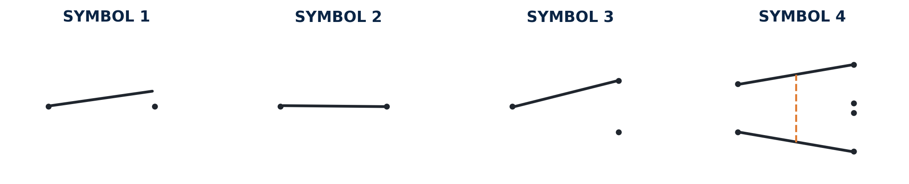
Label Symbols 1-4 as SPST N.O., SPST N.C., SPDT, or DPDT. Then circle the common terminal(s) on the SPDT and DPDT symbols.
What does the dashed line in the DPDT symbol mean? _________________________________________________________________

Part C - Read the Circuit
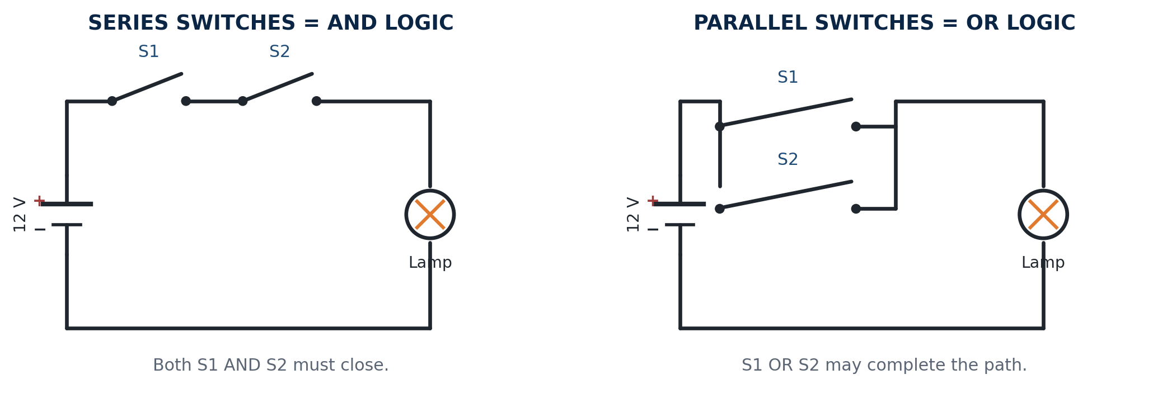
Figure A. Series and parallel multi-switch circuits.
1. In the series circuit, which switches must close for the lamp to turn on? __________________________________________________
2. In the parallel circuit, which switches may close for the lamp to turn on? __________________________________________________
3. What logic word describes the series circuit? What logic word describes the parallel circuit? __________________________________________________
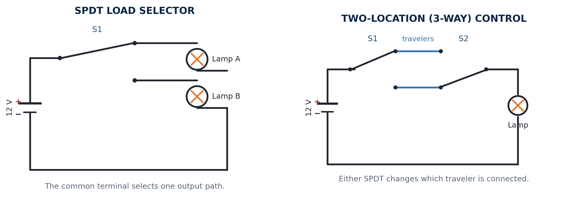
Figure B. SPDT load selection and two-location control.
4. Can both lamps be on at the same time in the basic SPDT selector? Explain. _______________________________________________________
5. What is the job of the common terminal on an SPDT switch? _______________________________________________________
6. What are the two wires between the three-way switches called? _______________________________________________________
7. Why can moving either three-way switch change the lamp state? _______________________________________________________

Part C - Read the Circuit (continued)
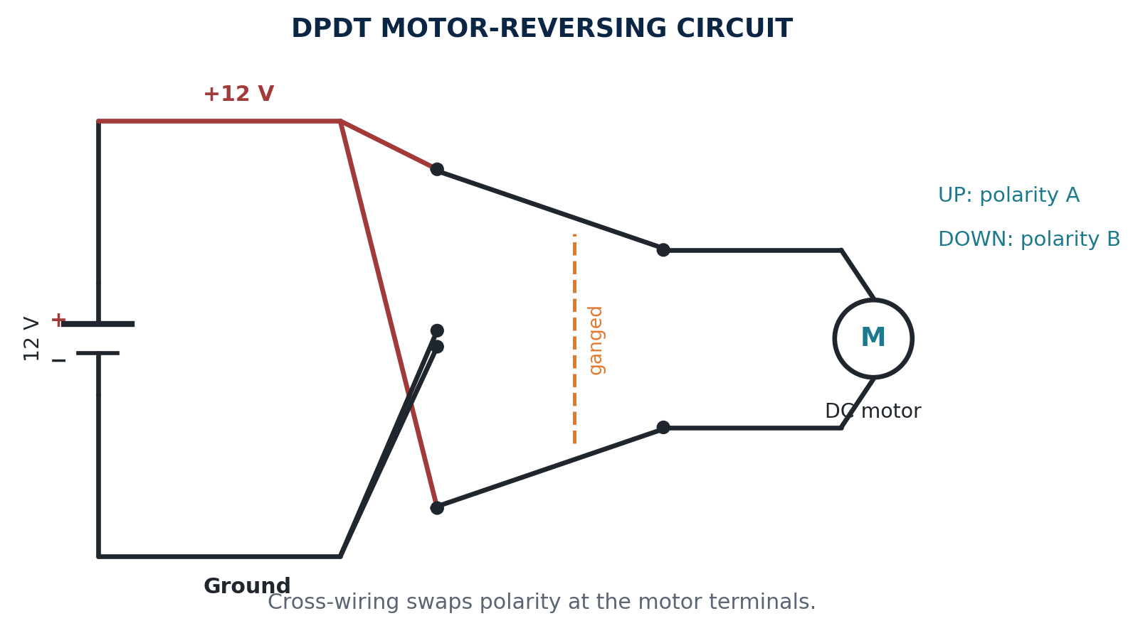
Figure C. DPDT motor-reversing circuit.
8. What electrical property changes at the motor when the DPDT switch changes position? _____________________________________________________
9. What dangerous wiring condition must be prevented in a polarity-reversing circuit? _____________________________________________________
10. If the motor winding is open, will the motor run even when the DPDT switch is correct? Why? _____________________________________________________

Explain the power path
Choose one circuit from Figures A-C. Complete the sentence: Power leaves ______, passes through ______, reaches ______, and returns through ______. The load operates when ______.

Part D - Voltage Prediction
Use battery negative as the meter reference. Predict each reading before connecting a meter.
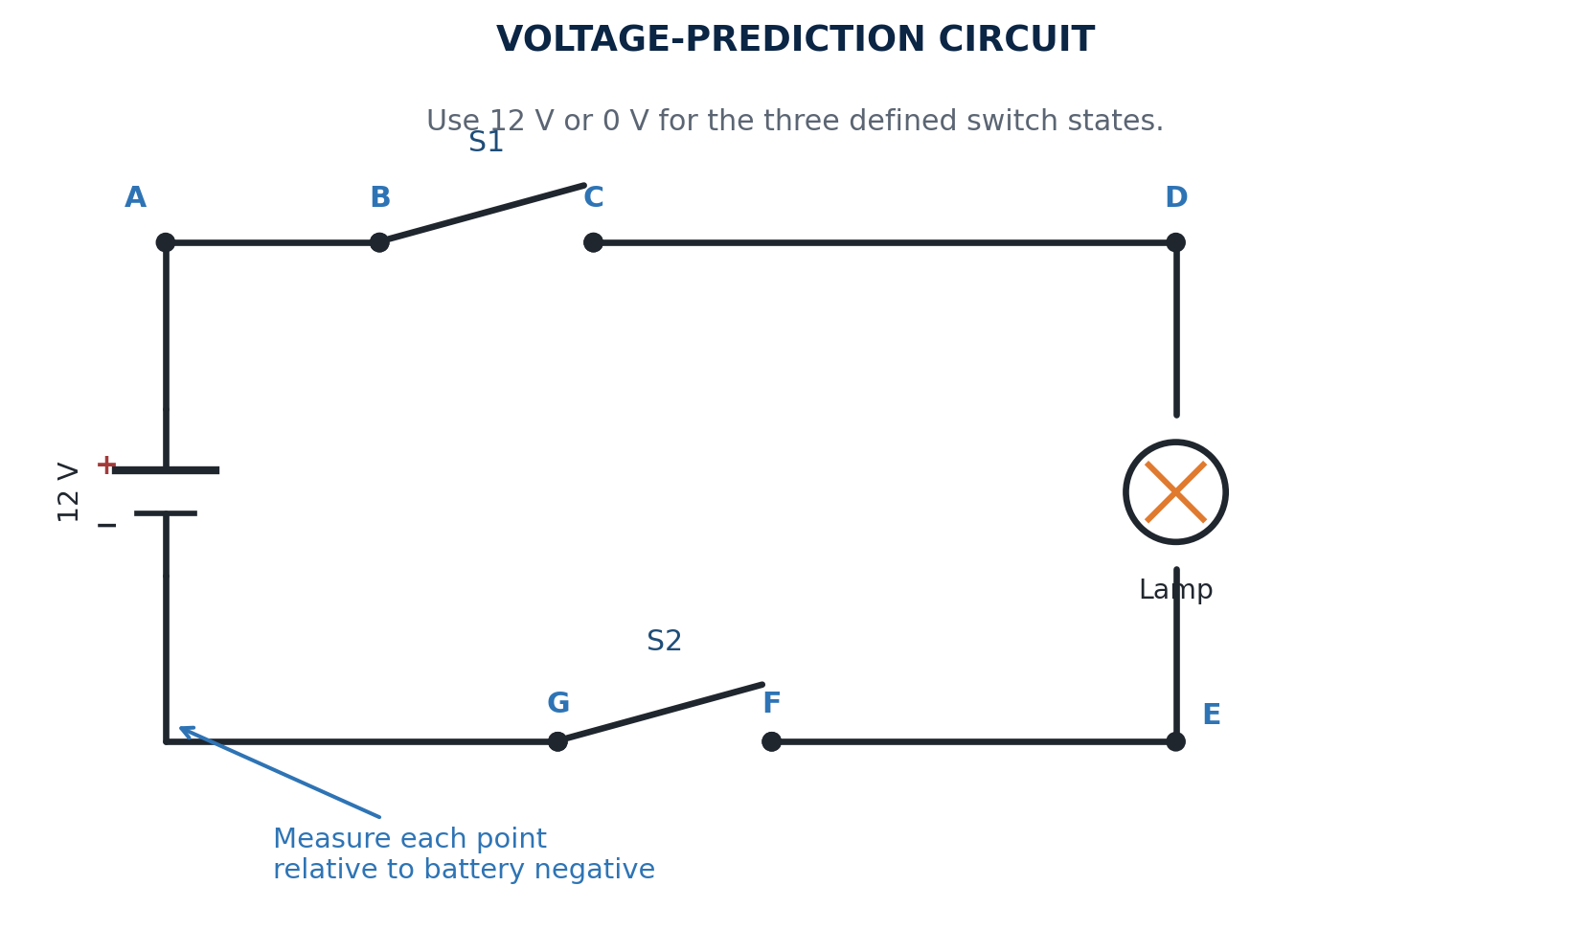
Figure D. Labeled test points for voltage prediction.
Test point | S1 OPEN / S2 CLOSED | S1 CLOSED / S2 OPEN | S1 CLOSED / S2 CLOSED
A
B
C
D
E
F
G

Part D - Circuit Results
Circuit result | S1 OPEN / S2 CLOSED | S1 CLOSED / S2 OPEN | BOTH CLOSED
Lamp state
Voltage across S1
Voltage across S2
Voltage across lamp

Explain why the voltage across a good closed switch should be nearly 0 V.

What does a reading near 12 V across an open switch tell you?

When both switches close, why does the lamp have approximately 12 V across it?

Part E - Circuit Design Challenges
DRAWING STANDARD Use clean wires and standard symbols. Label power, ground, every switch, every load, and important terminals. Show a fuse or current-limited source.

Challenge 1 - AND circuit
Draw two SPST switches in series controlling one lamp. Both switches must close for the lamp to operate.

Challenge 2 - OR circuit
Draw two SPST switches in parallel controlling one lamp. Either switch must be able to operate the lamp.

Challenge 3 - SPDT selector
Draw one SPDT switch selecting between Lamp A and Lamp B.

Part E - Circuit Design Challenges (continued)
Challenge 4 - Three-way control
Draw a two-location circuit using two SPDT switches and one lamp. Label the common terminals and travelers.

Challenge 5 - Motor reverse
Draw a safe DPDT circuit that reverses a DC motor. Show the cross-wiring and label motor polarity in both switch positions.

Part E - Master Design Challenge
USE ALL THREE Design one circuit that includes an SPST, an SPDT, and a DPDT. Suggested functions: SPST = master enable; SPDT = branch selector; DPDT = motor direction. Include at least one motor and one indicator lamp.

Challenge 6 - SPST + SPDT + DPDT
Draw and label your complete circuit.

Explain the job of each switch and describe exactly what happens in every switch position.

Part F - Build, Test, and Explain
Complete this page during the hands-on activity.
Step | Check | Done | Initials
1 | Power disconnected before wiring | ☐
2 | Fuse/current limit installed | ☐
3 | Power-to-ground short check completed | ☐
4 | Instructor/partner visual check completed | ☐
5 | Operation predicted before energizing | ☐
6 | Circuit energized and tested | ☐
7 | Voltage readings compared with predictions | ☐
8 | Circuit operation explained using the power path | ☐

Performance rubric - 20 points
Category | Points | Full-credit evidence
Schematic | 4 | Correct symbols, labels, and topology
Safety | 4 | Uses fuse/current limiting; avoids shorts; powers down before changes
Build quality | 4 | Neat, secure wiring; circuit operates as designed
Voltage prediction | 4 | Predictions are complete and compared with measurements
Explanation | 4 | Clearly explains the source-to-load-to-ground path and each switch's job

Instructor score: __________________
Reflection
What did the meter show that confirmed or corrected your prediction?

If the circuit did not work at first, what fault did you find and how did you prove it?

