VALVE BODY DISASSEMBLY
Component Location & Check-Off Task Sheet
Name | ____________________________ | Date | ______________
Team / Bay | ____________________________ | Instructor | ______________
TASK
Carefully disassemble the valve body. Use the exploded view to identify each component, place it in order, and check it off on page 2.
1. Set the valve body on a clean tray and compare its orientation to the diagram.
2. Remove one bore assembly at a time. Keep every valve, spring, plug, and retainer in removal order.
3. Match each part to its reference number and component name on page 2.
4. Do not mix similar-looking valves or springs. Ask the instructor before forcing or prying any component.
5. Complete the final inspection and obtain instructor initials before reassembly.
EXPLODED VIEW — USE THE REFERENCE NUMBERS TO IDENTIFY PARTS
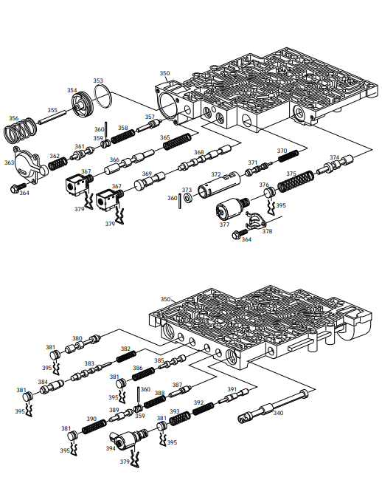
COMPONENT LOCATION CHECKLIST
Check each box only after the component has been removed, identified, and placed in the correct order.
Check | Ref. | Component | Check | Ref. | Component
☐ | 340 | Valve, Manual | ☐ | 373 | Plug, Bore
☐ | 350 | Valve Assembly, Control Body | ☐ | 374 | Valve, Actuator Feed Limit
☐ | 353 | Seal, Forward Accumulator Oil | ☐ | 375 | Spring, Actuator Feed Limit Valve
☐ | 354 | Piston, Forward Accumulator | ☐ | 376 | Plug, Bore
☐ | 355 | Pin, Forward Accumulator | ☐ | 377 | Pressure Control Solenoid
☐ | 356 | Spring, Forward Accumulator | ☐ | 378 | Retainer, Pressure Control Solenoid
☐ | 357 | Valve, Forward Abuse | ☐ | 379 | Retainer, Solenoid
☐ | 358 | Spring, Forward Abuse Valve | ☐ | 380 | Valve, Converter Clutch Signal
☐ | 359 | Plug, Bore | ☐ | 381 | Plug, Bore
☐ | 360 | Pin, Coiled Spring | ☐ | 382 | Spring, 4–3 Sequence Valve
☐ | 361 | Valve, Low Overrun | ☐ | 383 | Valve, 4–3 Sequence
☐ | 362 | Spring, Low Overrun Valve | ☐ | 384 | Valve, 3–4 Relay
☐ | 363 | Cover, Forward Accumulator | ☐ | 385 | Valve, 3–4 Shift
☐ | 364 | Bolt, Forward Accumulator Cover | ☐ | 386 | Spring, 3–4 Shift Valve
☐ | 365 | Spring, 1–2 Shift Valve | ☐ | 387 | Valve, Reverse Abuse
☐ | 366 | Valve, 1–2 Shift | ☐ | 388 | Spring, Reverse Abuse Valve
☐ | 367A | Shift Solenoid A (1–2–3–4) | ☐ | 389 | Valve, 3–2 Downshift
☐ | 367B | Shift Solenoid B (2–3) | ☐ | 390 | Spring, 3–2 Downshift Valve
☐ | 368 | Valve, 2–3 Shift | ☐ | 391 | Valve, 3–2 Control
☐ | 369 | Valve, 2–3 Shuttle | ☐ | 392 | Spring, 3–2 Control Valve
☐ | 370 | Spring, Accumulator Valve | ☐ | 393 | Spring, Bore Plug
☐ | 371 | Valve, Accumulator | ☐ | 394 | 3–2 Control Solenoid
☐ | 372 | Sleeve, Accumulator Valve | ☐ | 395 | Retainer, Bore Plug
FINAL INSPECTION
☐ All listed components were located and identified.
☐ Parts are arranged in correct removal order.
☐ No components are damaged, missing, or mixed with another group.
Instructor Initials: ____________________ Completion: ☐ Satisfactory ☐ Needs Review

