HANDS-ON TASK SHEET
Valve Body Disassembly & Component Location
Disassemble the assigned valve body and locate every component shown in the diagrams and identification list.
Student | ____________________ | Partner | ________________ | Date | ____________ | Valve Body ID | ____________
TASK PROCEDURE  1. Wear safety glasses; prepare a clean mat or compartment tray.  2. Photograph the valve body before removing plugs, clips, covers, or solenoids.  3. Disassemble one valve train at a time and control all spring tension.  4. Arrange every valve, sleeve, spring, plug, pin, and retainer in removal order.  5. Match each part to the diagram reference number and component list.  6. Check Located, record condition, and note the correct bore/location.  7. Obtain instructor approval before cleaning, moving, or reassembling parts.  8. Reassemble in correct order/orientation and verify free valve movement. | SAFETY & COMPLETION STANDARD  □ All numbered components are accounted for.  □ Valve trains remain separated and in correct order.  □ Installed orientation and bore location are verified.  □ Wear, scoring, sticking, damage, or missing parts are documented.  □ Instructor verifies the layout before reassembly.
  CAUTION: Springs may be under tension. Never force a spool valve, scratch a precision surface, or mix components between bores.
REFERENCE DIAGRAMS
Diagram A — Reference Nos. 340, 350, 379–395  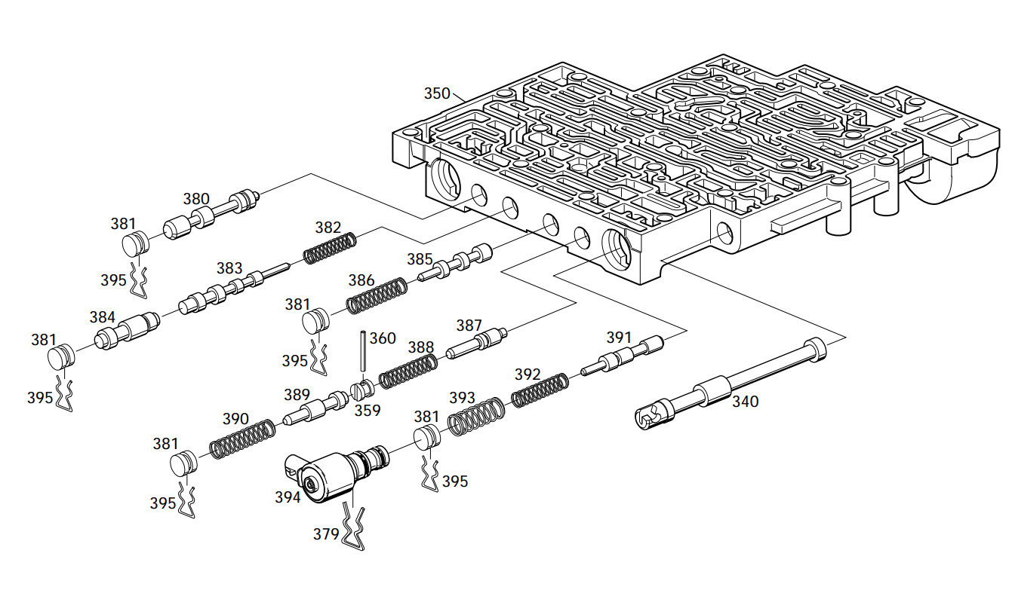 | Diagram B — Reference Nos. 350, 353–379  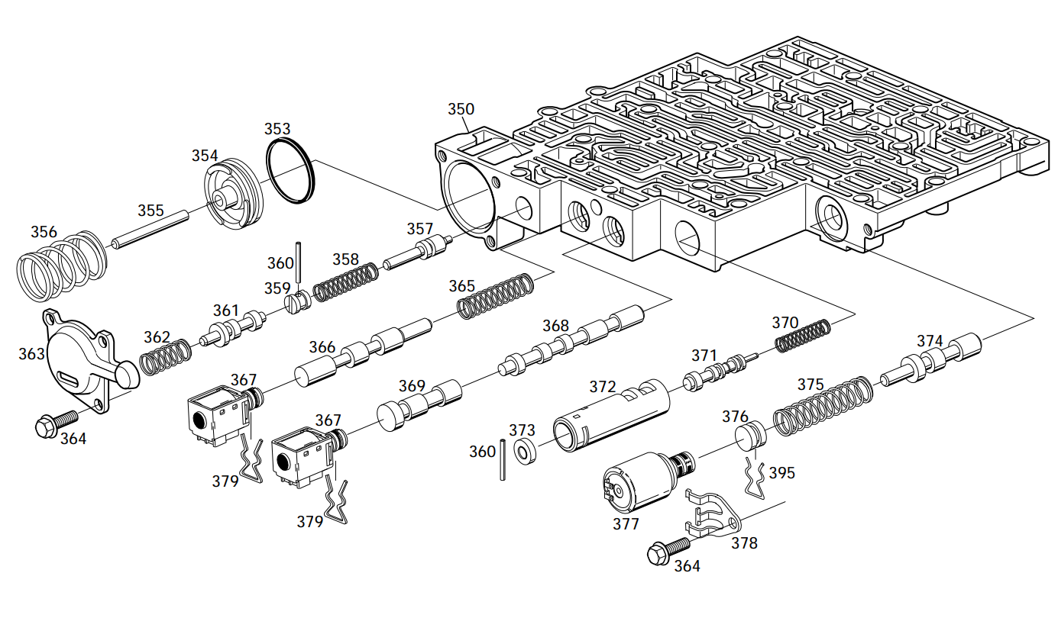
Instructor checkpoint before reassembly: □ Component layout verified Initials: __________
HANDS-ON TASK SHEET
Component Identification & Location Checklist
Locate each component in the disassembled valve body. Record its condition and bore/location.
  Ref. | Component | Located | Condition | Bore / Notes
  340 | Valve, Manual | □
  350 | Valve Assembly, Control Body | □
  353 | Seal, Forward Accumulator Oil | □
  354 | Piston, Forward Accumulator | □
  355 | Pin, Forward Accumulator | □
  356 | Spring, Forward Accumulator | □
  357 | Valve, Forward Abuse | □
  358 | Spring, Forward Abuse Valve | □
  359 | Plug, Bore | □
  360 | Pin, Coiled Spring | □
  361 | Valve, Low Overrun | □
  362 | Spring, Low Overrun Valve | □
  363 | Cover, Forward Accumulator | □
  364 | Bolt, Forward Accumulator Cover | □
  365 | Spring, 1-2 Shift Valve | □
  366 | Valve, 1-2 Shift | □
  367 | Shift Solenoid A (1-2/3-4) | □
  367 | Shift Solenoid B (2-3) | □
  368 | Valve, 2-3 Shift | □
  369 | Valve, 2-3 Shuttle | □
  370 | Spring, Accumulator Valve | □
  371 | Valve, Accumulator | □
  372 | Sleeve, Accumulator Valve | □
  Ref. | Component | Located | Condition | Bore / Notes
  373 | Plug, Bore | □
  374 | Valve, Actuator Feed Limit | □
  375 | Spring, Actuator Feed Limit Valve | □
  376 | Plug, Bore | □
  377 | Pressure Control Solenoid | □
  378 | Retainer, Pressure Control Solenoid | □
  379 | Retainer, Solenoid | □
  380 | Valve, Converter Clutch Signal | □
  381 | Plug, Bore | □
  382 | Spring, 4-3 Sequence Valve | □
  383 | Valve, 4-3 Sequence | □
  384 | Valve, 3-4 Relay | □
  385 | Valve, 3-4 Shift | □
  386 | Spring, 3-4 Shift Valve | □
  387 | Valve, Reverse Abuse | □
  388 | Spring, Reverse Abuse Valve | □
  389 | Valve, 3-2 Downshift | □
  390 | Spring, 3-2 Downshift Valve | □
  391 | Valve, 3-2 Control | □
  392 | Spring, 3-2 Control Valve | □
  393 | Spring, Bore Plug | □
  394 | 3-2 Control Solenoid | □
  395 | Retainer, Bore Plug | □
Student Findings | ____________________________________________________________ | Instructor Approval | ____________________________
Student Signature | ____________________________________ | Date / Score | ____________ ______ / 20

